**Experimental Application of Least-Squares Technique for Estimation of Double Layer Super Capacitor Parameters**

Nayzel Imran Jannif1*, Giansalvo Cirrincione2, Maurizio Cirrincione1,

Ali Mohammadi1., andGianpaolo Vitale3

1 University of the South Pacific, Suva, Fiji

2 Université de Picardie Jules Verne, Amiens, France

3 Consiglio Nazionale delle Ricerche (CNR)-ISSIA via Dante, Palermo, Italy

Email[:](mailto:ldia2007@ec-lille.fr) jannif_n@usp.ac.fj

*Abstract* -- In this paper the Parameters of a Double Layer Super Capacitor (DLC) Bank are experimentally identified on-line using Recursive Least Squares (RLS). In order to extract the signals suitable for the RLS a proper signal processing system has been implemented. Results have been verified with those obtained with an off-line common technique applied to the 2-branch model of the DLC.

*Index Terms*—Supercapacitors, signal processing, parameter identification, Recursive Least Squares.

# Introduction

As the world becomes more conscious about issues of climate change and greenhouse gas emissions, there is a strong move towards vehicles with electric propulsion systems. These Electric Vehicles (EV) have the advantage of no gas emissions as compared to the traditional vehicles with internal combustion engines. In particular, Supercapacitors (SC) play an important role in EV’s or Hybrid Electrical Vehicles (HVE) [1].

In these vehicles one of the major uses of SC’s is in the storage of energy coming from the regenerative braking system. SC’s are also useful for the reduction of battery current variations during the discharge phase [2].

SC’s have a number of advantages in comparison to batteries, like high power density approximately in the range of 5-15 kW.kg-1[3], or the ability to cycle power by charging and discharging energy at a more rapid rate than batteries. This capability gives SC’s a major lead for their application in EVs, where they are required to be continually charged/discharged without loss in performance – something which is difficult with batteries (PB, N-Cd, MNiH Li-ion) which have longer time constant [4].

Toward the purpose of controlling and managing a system where SC and batteries are present, proper modelling and characterization of the different components are key issues to improve the performance of EVs, and this involves also diagnosis of the state of health of the systems by using parameter estimation, voltage/current observation, proper sensor choices, and as far as SC are concerned, computation of the state of charge. Among the different types of SC, the widest spread in EV applications is the DLC ( Double –Layer Capacitors) with porous carbon electrodes, voltage of about 2V and capacitances as high as 1500 F [5]

Over the years, a number of methods have been developed and applied to the area of estimating parameters of a DLC, in particular trying to deal with their inherent nonlinearity that makes their external behavior differ from the one of common electrolytic capacitors. The first group of methods is based on electrochemical laws and describes the internal phenomena accurately; however, they are relatively intensive and not ideal for practical applications in power electronics and real-time control [3]. The second group of methods is based on the circuit model of the DLC. The most prominent is the Zubieta Method [5] where the charge and discharge of a SC is analyzed at prescribed points of the experiment and results in a 3-branch model of the DLC; however this method can be only applied offline. Faranda [12] proposed a simpler 2-branch model and proposes also an experimental method to determine the parameters of 2-branch model.

The third group of methods is based on the application of system identification concepts and in particular of soft-computing techniques like artificial neural networks to model the nonlinear behavior of the DLC. In [9], a feed forward artificial neural network structure with two hidden layers and with back-propagation training was applied to develop a dynamical model of the SC. However, this does not identify the parameters but rather predicts the behavior based on datasheet information.

Another set of methods developed in recent times applies the Kalman Filter (KF) to find the State of Charge and the parameters of the SC and is ever increasingly used. For example, [6] tuned the Extended Kalman Filter (EKF) so that the estimated outputs can reproduce the voltages at the equivalent capacitance terminals. Similar work was also carried out in[7] where the KF is used to track the unobservable internal states of the 3-branch DLC model. Yet another research [8] used the EKF to estimate the parameters of the SC online by using the linear impedance model in the frequency domain with 2 RC circuits in parallel and neglecting nonlinearities.

Towards the purpose of trying to estimate the DLC parameters on-line, methods based on Least Square (LS) techniques have become popular. A method which applies Recursive Least Squares (RLS) for on-line characterization of a SC has been presented in [10], but only the equivalent series resistance and the equivalent capacitance of a simple linear impedance have been retrieved. A Least Square method has been used in [11 to estimatethe parameters for the fractional order model of SC from a voltage excited step response. Another similar approach has been used in [13] to compute only some parameters of the 2-branch model, while [14] the SC is modeled using the Lagrange’s Equations.

This paper presents the estimation of the DLC parameters on the basis only of voltage and current at the terminals of a DLC or a DLC bank, similar to [13]. However, differently from [13], Rlea (the leakage resistance) and then the constant time of the second branch are both computed on-line.

The paper is organized as follows. Section II describes the 2-branch model, Section III presents the simulation results, Section IV the experimentation.

# Description and Analysis of the SC model

*A*. *The 2-Branch SC Model*

A DLC can be described by suitable circuits modelling its terminal behavior [5][6] and numerous models are discussed in literature. Among these the Classical Model, Non-Linear Capacitance Model, 3-branch model, 4-branch model, ladder model and transmission line model [3,5,12,13]. This paper, like [6] and [13] focusses on the 2-branch model sketched in Fig.1 for its simplicity and ease of analysis.

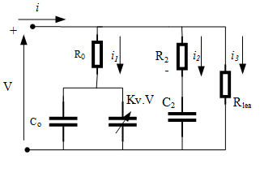

Fig. 1. 2-branch model of SC.

The 2-branch model is well known since it can accurately characterize the DLSC behavior during frequent charging-discharging cycles, which is best suited for EV’s applications where this behavior is exhibited [10].

The 1st branch consists of three components and models the voltage dependency of the capacitance. This branch gives the DLC a time constant in the order of seconds. The 2nd branch of the equivalent circuit consists of a resistance in series with a capacitance and models the charge redistribution with a time constant of minutes. The 3rd branch consists of one resistor and models the time varying self-discharge, which is modeled as a function of the SC terminal voltage.

*B.* *Analysis of the 2-Branch Model*

From fig. 1, and defining ${ τ}_{2}=R_{2 }C_{2 }$ (time constant of the second branch) then:

$i_{2}=C_{2 }\frac{dv}{dt}-τ_{2}\frac{di_{2}}{dt}$ (1)

And

$i_{2}=C_{2 }\frac{dv}{dt}+τ_{2}\frac{d(C_{0}+2kv)}{dt}\frac{dv_{1}}{dt}-τ_{2}\frac{di}{dt}+τ_{2}\frac{di_{3}}{dt}$ (2)

Since: $i_{1}=(C_{0}+2k_{v}v_{1}) \frac{dv_{1}}{dt}$ (3) [13]. From above it follows:

$i_{2}=C_{2 }\frac{dv}{dt}+τ_{2}C_{0}\frac{dv_{1}}{dt}+τ_{2}2k_{v}v\frac{{d^{2}v}_{1}}{dt^{2}}+τ_{2}2k_{v}{\left(\frac{dv}{dt}\right)}^{2}-τ_{2}\frac{di}{dt}+\frac{τ_{2}}{R_{3}}\frac{dv}{dt}$ (4)

𝐼fRo is assumed to be negligible ($v_{1}=v)$, as is reasonable for DLC and considering $i=i_{1}+i_{2}+i_{3}$, then :

${i+τ_{2}\frac{di}{dt}=C}_{0}\frac{dv}{dt}+2k_{v}v\frac{dv}{dt}+ C_{2 }\frac{dv}{dt}+τ_{2}C_{0}\frac{d^{2}v}{dt^{2}}+{2τ}_{2}k_{v}v\frac{d^{2}v}{dt^{2}}+{2τ}_{2}k_{v}{\left(\frac{dv}{dx}\right)}^{2}+\frac{τ_{2}}{R_{3}}\frac{dv}{dt}+\frac{v}{R_{3}}$ (5)

This equation gives rise to a linear matrix equation, in the same fashion as in [13], as follows

$Aα≈b$ (6)

where $α={(α_{1},α_{2}, α_{3},α_{24},α_{5},α_{6})}^{T}$ is the unknown column vector whose values are **:**

(7 a,b,c,d,e,f)

$${∝_{1}=C}_{0}+C_{2 }+{τ_{2}}/{R_{3}}$$

$$∝_{2}=2k_{v}$$

$$∝_{3}=τ_{2}C_{0}$$

$$∝_{4}=τ_{2}$$

$$∝_{5}=2k_{v}τ_{2}$$

$$∝_{6}=1/{R_{3}}$$

Note that the nonlinear constraint is present $∝_{5}=∝_{2}∝_{4}$

The $A$ is a matrix whose columns are

$$A=[\frac{dv}{dt}; v\frac{dv}{dt} ; \frac{d^{2}v}{dt^{2}} ; -\frac{di}{dt} ; v\frac{d^{2}v}{{dt}^{2}}+{\left(\frac{dv}{dt} \right)}^{2}; v]$$

And $b$ = [*i*] is the vector of currents. The length m of each column corresponds to the number of data points.

Since the parameters are to be estimated on-line, one of the most suitable techniques could be the Recursive Least Squares (RLS), and this paper follows the algorithm presented in [15, ch.9].

It must be remarked that in order to retrieve all of the parameters, the matrix A must be full rank and that transient information must be exploited. Indeed, if a constant current *i* is given, then the matrix becomes rank deficient in steady-state, while the information on parameter $∝_{4}$ is lost. Remark however that in these conditions the constraint disappears. In the same way any experiment corresponding to a ramp voltage without transient results in the 2nd derivative of the voltage to be always null and the A matrix to be of rank 2 so that only 2 parameters can be retrieved, while $∝_{3}$ cannot be estimated. The general idea is to give enough information in the input signals so that the A matrix is never rank deficient and all parameters can be identified, in compliance with the persistent excitation theorem.

*C.* *Signal Processing System*

In order to process on-line the voltage and currents a suitable signal processing system must be devised as explained in [13] and summarized in Fig 2 .

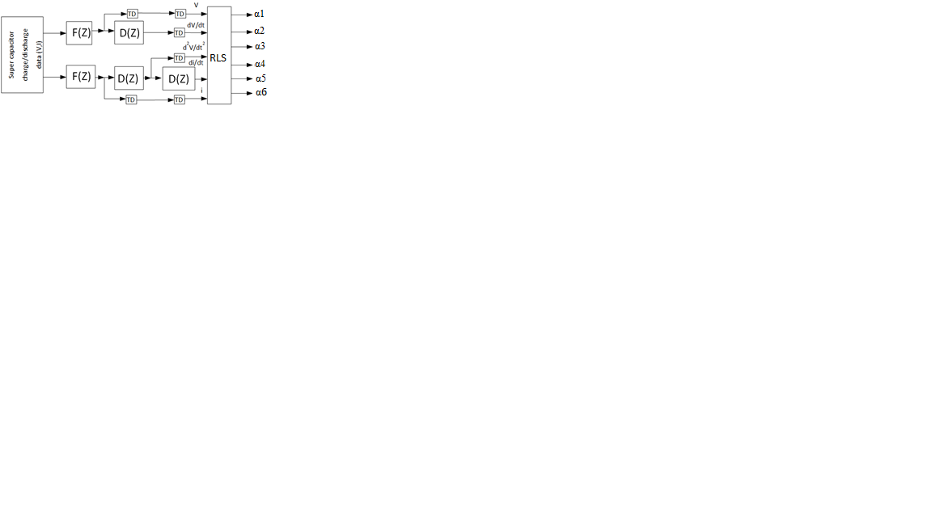

Fig. 2. Block diagram of the signal processing system

The data pre-processing scheme has a number of stages. The data is placed through a digital low-pass filter F(z) (fig. 3) realized by a FIR (with a constant group-delay of 216 samples) to remove any high frequency noise that can affect the subsequent derivation. For a real EV application an analog anti-aliasing filter should be added [13]. The filtered data is then taken through identical digital derivative filters (fig4) to populate the A matrix. A time delay is implemented in order to synchronies all five streams of data to RLS by using the information of the group-delay.



Fig. 3 The magnitude frequency response of the FIR F(z)



Fig. 4 The frequency response of the derivative filter D(z)

*B. Verification on Simulink and Matlab*

The RLS and proposed system have been verified on Matlab®- Simulink® environment by implementing the dynamical equations of the circuit of fig 2 given below:

$\frac{dv_{1}}{dt}=\frac{1}{C_{1}G_{||}}\left[G_{1}\left(G_{1}-G_{||}\right)v_{1}+G_{1}G_{2}v_{2}+G_{1}I\right]$

$\frac{dv_{2}}{dt}=\frac{1}{C_{2}G_{||}}\left[G_{2}\left(G_{2}-G_{||}\right)v_{2}+G_{1}G_{2}v_{1}+G_{2}I\right]$ (8)

$$v=\frac{G_{1}v_{1}+G_{2}v_{2}}{G_{||}}$$

where $G_{i}=\frac{1}{R_{i}}$ and $G_{||}=\frac{G_{1}G_{2}}{G_{1}+G_{2}}$ and ${C_{1}=C}_{0}+2k_{v}v_{1}$

III. Simulation Results

In simulation an input signal has been given made up of a current ramp. To speed up the simulation and verify the goodness of the method, a low Rlea has been given to the model. A forgetting parameter of 0.98 and a low sigma value for the initialization were given to the RLS algorithm.

The results from the proposed system show a good correlation as shown in Table 1 below

TABLE I

estimation Results by Simulation

|  |  |  |  |  |
| --- | --- | --- | --- | --- |
| Parameters | Unit | True | Estimated | % Error |
| C0 | F | 38 | 41.1 | 8 |
| KV | F/V | 0.98 | 0.97 | 1.02 |
| R2 | Ω | 10 | 9.86 | 1.4 |
| C2 | F | 13 | 10.23 | 21 |
| R3 | Ω | 10 | 10.07 | 0.7 |



Fig. 5 RLS Estimated Parameter of R3



Fig. 6 RLS Estimated Parameter of C2 + C0



Fig. 7 RLS Estimated Parameter of KV

The simulation results in Fig.s 5-7 show an acceptable convergence to the real values, with a high percentage error in the estimation of C2. In any case the hardest values to estimate are those connected to the columns with the second derivative, i.e. $∝_{3}$ and $∝_{5}$ with resulting difficulties in estimating $τ_{2}$. The accurate value of R3 permits however to compensate partially this incertitude as shown in fig.7 where the sum of C2 and Co is estimated.

IV. Experimentation

*A. The Super Capacitor Bank*

Fig. 8 shows the experimental rig, which is composed of a “GreenCap” MH47765 Super Capacitor bank of 6 × DLSC connected in series. Each capacitor is 500F with a voltage rating of 2.7V.

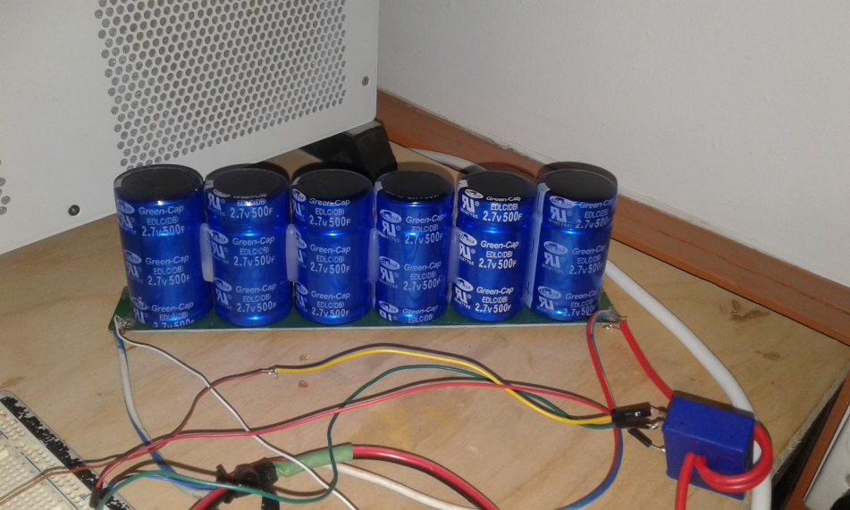

Fig. 8. The SC Bank used for this research work

The series configuration has resulted in the net capacitance of the bank, CSC, becoming 83.33F. The voltage rating of the SC bank is calculated to be 16.V

A 10Ω load resistor has been used in the charge/discharge circuit which results in a Time Constant, τ, for the SC bank:



Some of the other important parameters of the SC bank from the data sheet are presented here:

* ESR @ 1KHz = 18 mΩ
* ESR in DC = 30 mΩ
* Max. Peak Current = 20 A
* Max. Continuous Current = 167 A
* Rated Voltage = 15 V

*B. Experimental Setup*

The SC is placed in a dual Charge/Discharge circuit where a two-way switch is used to change the SC connection from the Charging system to the Dis-charging system as shown in fig. 9. In both of these cases, the Data Acquisition System remains connected to the terminals of the SC.

The Data Acquisition System consists of the dSpace Autobox DS1007 System. The DS2004 card was mostly used, which is the dSpace card used to read an Input Analog Signal. The input range of the DS2004 card is 0–10V. Since the full charge of the SC is 16.2V, a voltage divider was used as an intermediary to the dSpace system.

The sampling frequency of 1 kHz was selected for the charge and discharge tests.



Fig. 9. The experimental Charge/Discharge circuit connected to the Data Acquisition system.

The experimental a test bench is shown in fig. 10.

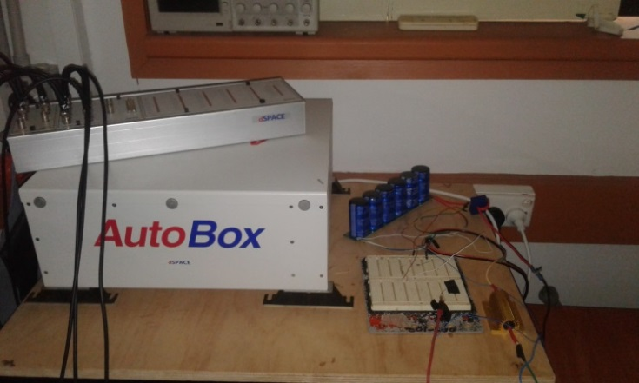

Super

capacitor

bank

10Ω

Fixed

Load Resistor

Fig. 10 Experimental setup showing SC bank

*C. Charge-Discharge Curves*

The following graph in fig. 11 shows the charge and discharge curves of the Super Capacitor obtained experimentally.

# 

Fig. 11 Experimental Charge and Discharge Curve of the SC Bank

*D. Results*

RLS has been used to compute the parameters of the above SC on MatLab. In order to verify the results as found by RLS, Zubeita experimental technique used. The results are shown in table 2 below.

This table shows that the RLS method computes the parameters of the DLC comparable to those of Zubieta.

TABLE II

Experimental Results

|  |  |  |  |
| --- | --- | --- | --- |
| Parameters | Unit | Zubeita Method | RLS |
| C0 | F | 10.8 | 11.4 |
| KV | F/V | 8.6 | 9.1 |
| R2 | Ω | 10.8 | 8.9 |
| C2 | F | 9.3 | 11.2 |

 Fig. 12 Voltage curves of the DLC obtained with the RLS and the Zubieta method

Fig 12 shows the curve obtained by using eq. (8) with the parameters obtained with the 2 different methods, proving the validity of the proposed approach.

# Conclusion

This paper proposes the RLS as a technique to use for on line parameter estimation to characterize a Double-Layer Capacitor. The technique derives from a voltage-current relationship involving derivative, whereby a proper signal processing system has been implemented. This method is capable of estimating all of the parameters of a DLC 2-branch model and can be used either in adaptive control or on-line diagnosis of DLC, particularly in automotive applications.

ACKNOWLEDGMENT

The authors would also like to acknowledge the Research Assistants (Hiye Mudaliar and Dhirendran Kumar) at the SEP-USP for their assistance in the experimental part of this paper.

# References

1. Ehsani, Yimin Gao, and Ali Emadi. *Modern electric, hybrid electric, and fuel cell vehicles: fundamentals, theory, and design*. CRC press, 2009.
2. Cao, Jian, and Ali Emadi. "A new battery/ultracapacitor hybrid energy storage system for electric, hybrid, and plug-in hybrid electric vehicles." *IEEE Transactions on power electronics* 27, no. 1 (2012): 122-132.
3. Devillers, Nathalie, Samir Jemei, Marie-Cécile Péra, Daniel Bienaimé, and Frédéric Gustin. "Review of characterization methods for supercapacitor modelling." *Journal of Power Sources* 246 (2014): 596-608.
4. Rafik, Fouad, Hamid Gualous, Roland Gallay, Albert Crausaz, and Alain Berthon. "Frequency, thermal and voltage supercapacitor characterization and modeling." *Journal of power sources* 165, no. 2 (2007): 928-934.
5. Zubieta, Luis, and Richard Bonert. "Characterization of double-layer capacitors for power electronics applications." *IEEE Transactions on industry applications* 36, no. 1 (2000): 199-205.
6. Alonge, Francesco, Giulio Rodonò, Maurizio Cirrincione, and Gianpaolo Vitale. "Supercapacitor diagnosis using an extended Kalman filtering approach." In *Environment and Electrical Engineering (EEEIC), 2016 IEEE 16th International Conference on*, pp. 1-6. IEEE, 2016.
7. Nadeau, Andrew, Gaurav Sharma, and Tolga Soyata. "State-of-charge estimation for supercapacitors: A kalman filtering formulation." In *Acoustics, Speech and Signal Processing (ICASSP), 2014 IEEE International Conference on*, pp. 2194-2198. IEEE, 2014.
8. Zhang, Lei, Zhenpo Wang, Fengchun Sun, and David G. Dorrell. "Online parameter identification of ultracapacitor models using the extended Kalman filter." *Energies* 7, no. 5 (2014): 3204-3217.
9. Dănilă, Elena, Gheorghe Livint, and Dorin Dumitru Lucache. "Dynamic modelling of supercapacitor using artificial neural network technique." In *Electrical and Power Engineering (EPE), 2014 International Conference and Exposition on*, pp. 642-645. IEEE, 2014.
10. Reichbach, Noam, and Alon Kuperman. "Recursive-least-squares-based real-time estimation of supercapacitor parameters." *IEEE Transactions on Energy Conversion* 31, no. 2 (2016): 810-812.
11. Freeborn, Todd J., Brent Maundy, and Ahmed S. Elwakil. "Measurement of supercapacitor fractional-order model parameters from voltage-excited step response." *IEEE Journal on Emerging and Selected Topics in Circuits and Systems* 3, no. 3 (2013): 367-376.
12. Faranda, R. "A new parameters identification procedure for simplified double layer capacitor two-branch model." *Electric Power Systems Research* 80, no. 4 (2010): 363-371.
13. Pucci, M., G. Vitale, G. Cirrincione, and M. Cirrincione. "Parameter identification of a Double-Layer-Capacitor 2-branch model by a least-squares method." In *Industrial Electronics Society, IECON 2013-39th Annual Conference of the IEEE*, pp. 6770-6776. IEEE, 2013.
14. Vitale, G., “Supercapacitor Modelling by Lagrange’s Equations”, In *Modern Electrical Power Engineering (ICMEPE), 2016, International Conference on,* pp. 127-132 EEEJ 2016
15. Haykin S. , *Adaptive Filter Theory*, *4th Ed*., Prentice-Hall, 2002