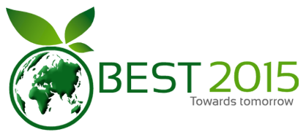

**UNDERTAKING BY AUTHORS**

I/We, the undersigned, give an undertaking to the following effect with regard to our article entitled …… Powder Metallurgy a Potential Green Manufacturing Processes: A Review …… submitted for publication in the proceedings of 2nd International Conference on Bioenergy, Environment and Sustainable Technologies –BEST2015. The article mentioned above has not been published or submitted to or accepted for publication in any form, in any other conference/journal. I/we declare, I/We contributed significantly towards the research study i.e., conception, design and/or analysis and interpretation of data.

|  |  |  |
| --- | --- | --- |
| S. No | Author Name | Signature of author |
| 1 | A. Rajeshkannan | *signature* |
| 2 | R.S. Devi |  |
| 3 | --- |  |
| 4 | --- |  |