Abstract:
Since the introduction of MOOCs, they have attracted much attention in both developed and developing educational contexts. However, what works in resource- and technology-rich environments does not work all that well in resource-poor contexts. Metaphorically speaking, what is good for the goose is not necessarily good for the gander. In developing contexts, where direct access to learning opportunities is either lacking or restricted for various reasons, a different kind of MOOC architecture is required. Contemporary MOOCs emanating from developed educational contexts tend to include learning resources that require large bandwidth to access, thereby moving them beyond the reach of the majority of learners in developing educational contexts. To be able to serve the needs of learners in resource-poor educational contexts, it is imperative that MOOCs are designed with a different perspective including innovative architecture and educational resources. In response, this chapter describes those early efforts in the development of MOOCs at the University of the South Pacific, and especially the focus on climate change which is an area of not just local and regional interest, but of global concern.

Running Head Right-hand: A Different Kind of MOOC Architecture for Emerging Economies
Running Head Left-hand: Deepak Bhartu and Som Naidu

8

A Different Kind of MOOC Architecture for Emerging Economies in Oceania and the Pacific
Deepak Bhartu and Som Naidu
While the notion of online education is not new, many Higher Education Institutions (HEI), policy makers and private companies from all over the world have started to explore, create and offer Massive Open Online Courses or MOOCs. MOOCs are large online courses that provide learners free and open access to learning opportunities via the Web. Due to growing interest in MOOCs from stakeholders, the MOOC movement has grown rapidly since Stanford University offered three of its courses free of charge to about 400,000 participants worldwide in 2011 (
Rodriguez, 2012;
Ng & Widom, 2014).
In developed countries, Internet services are relatively cheap or free; however, the same is not true for the emerging economies of the world (
Kirkpatrick, 2018). In these contexts, there is often no access to the Internet; and when there is access, it is intermittent, weak, unreliable and, above all, very expensive. These challenges are certainly true of the South West Pacific region and the member countries of the University of the South Pacific (USP). The USP member countries are Cook Islands, Fiji, Kiribati, Nauru, Niue, Republic of Marshall Islands, Samoa, Solomon Islands, Tokelau, Tonga, Tuvalu and Vanuatu (see Figure 8.1). For these reasons, one could argue that popular models of MOOCs, with their reliance on rich multimedia content including videos and frequent interaction among student peers, and course support personnel, often including the MOOC instructors, is an ineffective and unsustainable model across the USP region (
Bates, 2015). Until connectivity improves or becomes cheaper, a different model of MOOCs will have to be imagined for the South Pacific Region and similar emerging economies.
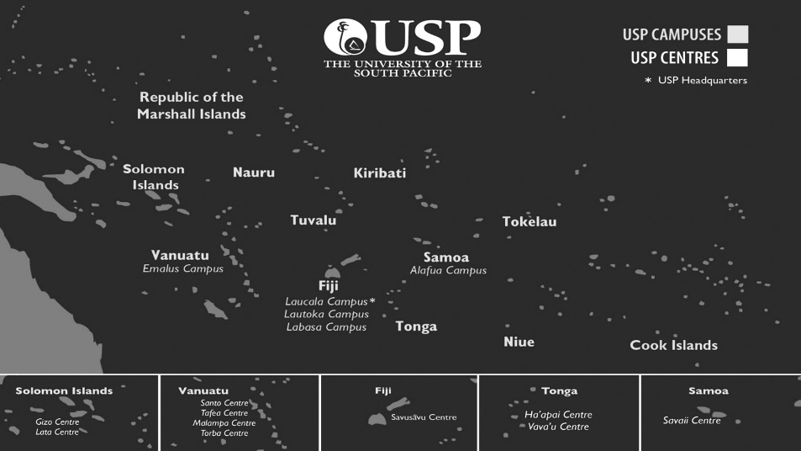
Figure 8.1 The USP Footprint
USP has a very strong pedigree in open, flexible and distance learning with the use of a wide range of technologies and online resources. The University has been involved in distance education since its inception and has been providing high-quality education to the remotest parts of the region. Given the digital revolution and USP’s leadership mandate in the region’s ICT development, USP has seen a transition in its modes of learning and teaching from a reliance on print and face-to-face instruction to an increasing use of blended and online technologies to make learning more open and accessible. MOOCs align well with this trajectory and USP’s leadership mandate and its current Strategic Plan 2019–2024.
MOOCs are based on the premise that knowledge and understanding is best developed through communication, collaboration and connection among participants (see
Siemens, 2008–2012). However, a vast majority of the MOOCs offered to date replicate the structure of traditional university courses. These types of MOOCs, more commonly known as xMOOCs, offer structured learning experiences with an instructor providing guidance on the course via a course syllabus and guiding participants through their learning journey in the course (
Sokolik, 2014).
Yousef et al. (2014) represents the components of xMOOCs graphically as shown in Figure 8.2 (p. 13)
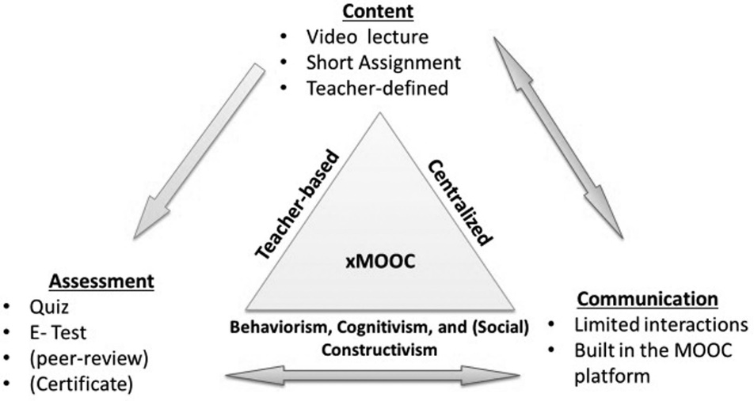
Figure 8.2 xMOOC Components
In this chapter, we describe our early efforts in the development of the first MOOC for USP in the area of Climate Change, which has relevance for the global audience as well. MOOCs offer the University of the South Pacific an opportunity to reach out to many more of its students in the region and at the same time reach out to those outside the region so that they too can benefit from the unique knowhow and expertise and experience of this region.

Structure of the Climate Change and Pacific Islands MOOC
The member countries of USP region and their people are heavily dependent on their environment for their livelihood, and most at risk when anything threatens it such as climate change. Climate change is one of the biggest challenges facing the region today. In fact, it has already led to significant rise of sea levels and changes in weather patterns.
The MOOC on Climate Change and Pacific Islands was a funded project of UNESCO’s CONNECT ASIA programme. The project was implemented in 2015 by USPs Pacific Centre for Environment and Sustainable Development (PaCE-SD) and was the first MOOC that USP offered (www.usp.ac.fj/index.php?id=19481). The course was designed to target environmental professionals, existing tertiary students, and especially those working in governments or NGOs who wished to enhance their understanding of climate change and its impacts on Pacific Island Countries (PICs) and communities. Its main focus was to give an overview of the science of climate change, its effects across the Pacific, highlighting the particular challenges and vulnerabilities of PICs. In addition, it was intended to help build resilience for people involved with planning for natural resources, economic and social development, and protecting the natural environment. Since it was the first time that USP offered a MOOC, a MOOC development cycle was created (see Figure 8.3). The development cycle defined tasks which had to be achieved at each phase and served as a method of quality control.
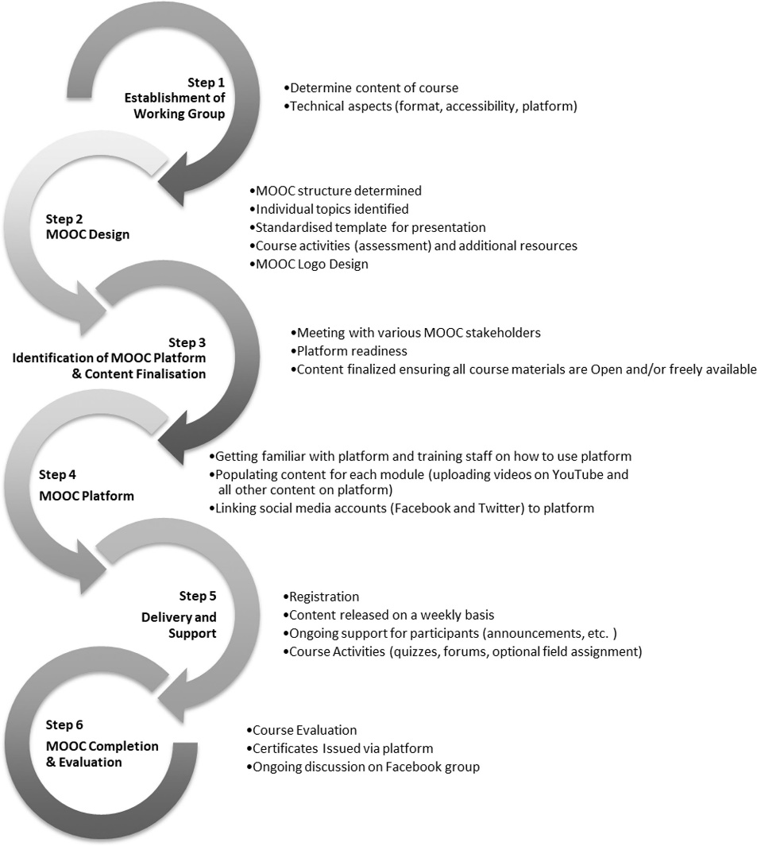
Figure 8.3 MOOC Development Cycle
The MOOC was divided into five core modules of one week each and each module focused on a specific theme. In addition to these five key modules, there was also an “Overview” module in the first week and a “Concluding” module in the last week. The Overview module introduced participants to the course guide that explained the course structure (including the weekly schedule), course learning outcomes and course certification criteria. It also included an introductory video to set the scene for the course and invited participants to introduce themselves to the online community. The concluding module entitled “The Journey Ends . . . “ provided a summary of the course and focused on the course evaluation and the certification requirements for the participants.
The first module (Climate Change Science and the Pacific Islands) provided important insights into the rapidly developing realm of climate science to enhance understanding of the scientific basis of the threats of the impacts of climate change. The second module (Disaster Risk Reduction and Ecosystem Services) focused on the causes and impacts of disasters for PICs and provided an overview of disasters, disaster preparedness, mitigation and rehabilitation. It also looked at the causes and effects of climate change on ecosystems and the inter-linkages between climate change and ecology, ecosystem-based adaptation and the importance of incorporating traditional and cultural approaches. The third module (Impact of Climate Change and Food Security) looked at building resilience in PICs through understanding risks to food security, reducing vulnerability through optimal choices of crops and enhancing adaptive capacity by better anticipating natural variability and climate change impacts. This particular module also focused on key lessons learned from the use of weather information for food security at the community level and the impacts of tropical cyclones on food security. The fourth module (Options for Pacific Islands to Mitigate GHG Emissions and Build Their Resilience) focused on how the Pacific can both reduce its own carbon emissions and build the resilience of PICs in the face of increasing climate change impacts for two key sectors: energy and transport.
The fifth module (Field Visits: Community Vulnerability and Adaptation Assessment) provided participants the opportunity to undertake practical field work in a community of their choice using vulnerability and adaptation toolkits that had been developed by PaCE-SD staff and used in over 100 communities. A key incentive for this assessment was that assessments were showcased in the Pacific stand by PaCE-SD staff at the Conference of Parties (COP) 21; this was also known as the 2015 Paris Climate Conference which raised awareness of Climate Change in the Pacific considerably.

During the re-run of the course in 2017, all the core modules were designed to have a similar structure to foster rich learning experiences and student success except for the fifth module, which was assessment-only. These learning experiences included two-core learning resources in the form of lectures (video lecture, PowerPoint slide with narration, lecture script and audio file of video lecture), additional learning resources, collaboration in discussion forums and social media integration (Facebook and Twitter) and quizzes (multiple choice type) for the two-core learning resources.

Strategies to Support MOOCs for Emerging Economies
To begin with, it was crucial to ensure that all learning resources in the course were either open or freely available on the public domain. This requirement was to make certain that participants did not need any special privileges or incur additional costs to access the resources (
Omoeva, Moussa, & Gale, 2018). In addition, all materials were vetted for copyright compliance and any new content created as part of the MOOC was released under an open license.
Considering the connectivity and technical limitations regarding Internet bandwidth in the South Pacific Region, several short video lectures (5–20 minutes) were developed to prevent wait time in accessing the material either while downloading or streaming. Furthermore, to reduce the size of the video files, only a brief introduction and conclusion was included within the video itself. However, most importantly all core learning resources (lecture notes) were made available in multiple formats to ensure that participants could access the resources with minimal connectivity. These included documents with transcripts and an audio file of the core video lecture. Additionally, participants themselves also took notes from each lecture and shared these with fellow participants.
During the first offer of the course in 2015, USP in collaboration with the Commonwealth of Learning (COL) used a platform called “mooKIT” to offer the course (www.col.org/news/connectionsedtech-news/connections-november-2015-vol20-no3). The mooKIT platform developed by the Indian Institute of Technology Kanpur has been specifically designed for Internet access challenged situations and is able to adjust to variable bandwidth (i.e., poor, unstable and expensive). The platform includes a feature utilized by about 8% of the total participants, whereby the course content could be delivered to participants over a phone (mobile phone or landline) without the need for Internet connectivity. Content was transmitted in audio format through a voice call at no cost to the participant.
Another important aspect of the MOOC was the integration of Facebook and Twitter within the platform. The platform would allow participants to use their social media accounts to track and post to discussions and not have to visit the course space to learn of new developments as they were alerted via social media (
Prabhakar, Shukla, & Shukla, 2016).

Results and Success Stories
The Climate Change and Pacific Islands MOOC has run twice so far (i.e., in 2015 and 2017) with over 1,500 participants in each offering (see Table 8.1). Participants from over 60 countries around the globe registered for the course with the majority of the participants from Fiji and about 10% from outside the Pacific region. The course offered free certification of participation to all those who met the criteria of “attempting and scoring at least 50% or more in 5 out of 8 quizzes.” This particular MOOC has seen impressive completion rates at an average rate of 33.25% compared to the world average of less than 15% (
Jordan, 2015).
Table 8.1 MOOC Enrollments and Completion Rates
[Note to author: Tables are better viewed when changing your 'MS Word settings' to 'Web view'].
Year of Offering | 2015 | 2017
Number of Registered Participants | 1,534 | 1,636
Number of Participants Completing | 411 | 650
Completion Rate | 26.8% | 39.7%
In addition to the relatively high completion rate for a MOOC, learner engagement was significantly higher than a typical face-to-face university course for the same discipline. Such results could be attributed to the effective use of discussion forums and integration of social media in the course. From an instructor’s perspective, the ability to view interaction between participants with many of the questions/queries being answered by fellow participants themselves was fascinating. In effect, peer-to-peer learning was a key aspect of this MOOC on Climate Change and the Pacific Islands. The level of excellent thought and discussions by participants provoked by the instructors, and the interaction between participants from different parts of the world was of high value (e.g., discussions on use of community-based participatory actions and traditional knowledge between Europeans, South Americans and Pacific Islanders). Instructors were also generally astounded by the level and scope of cross-cultural exchanges that transpired on social media. Stated another way, it was immediately apparent that participants were quite familiar with social media and were able to assuage concerns about the course using them. The MOOC also encouraged more and free discussions of thoughts and ideas in comparison to traditional courses. The Social Network Graph detailed in Figure 8.4 illustrates how participants made use of social media during the course from the first week to the last week.
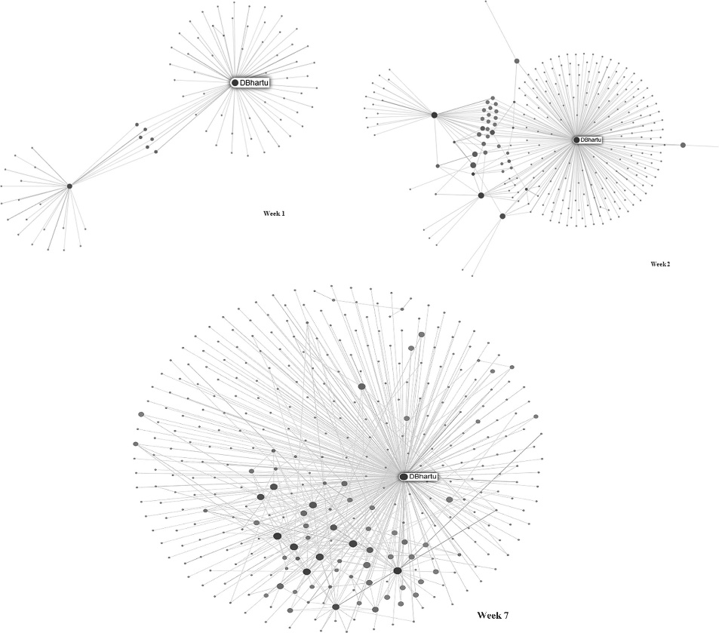
Figure 8.4 The Social Network Graph
Importantly, 10 participants from the course in 2015 applied for a Post Graduate programme in Climate Change offered by USP. As such, the MOOC directly contributed to transfer rates. Table 8.2 shows the average pass rate for the quizzes.
Table 8.2 Summary of Quiz Responses for Certification
Quiz No. | No. of Responses |  | Pass Rate (50% or more) |  | Average Mark
 | 2015 | 2017 | 2015 | 2017 | 2015 | 2017
1 | 590 | 808 | 90% | 98% | 76% | 92%
2 | 529 | 779 | 89% | 97% | 68% | 83%
3 | 485 | 731 | 78% | 91% | 62% | 70%
4 | 454 | 697 | 89% | 93% | 74% | 77%
5 | 439 | 680 | 96% | 94% | 85% | 81%
6 | 430 | 665 | 98% | 99% | 83% | 85%
7 | 413 | 658 | 92% | 95% | 84% | 84%
8 | 400 | 646 | 79% | 80% | 65% | 65%

Concluding Remarks
One of the 17 Sustainable Development Goals (SDG) of the United Nations is to have Quality Education (SDG 4). Its intention is to “Ensure inclusive and equitable quality education and promote lifelong learning opportunities for all” (
SDG Compass, 2015). The MOOC on Climate Change and Pacific Islands displayed how island nations face a unique set of challenges to sustainable and prosperous development. It presented different aspects of the topic, from the scientific background to impacts on different sectors and the various options for the Pacific Islands to reduce their already minimal contribution to the global greenhouse gas emissions.
Furthermore, although MOOCs were initially seen as a means of raising the institutional profile and reputation, there were clearly other associated benefits for institutions and academics. Such benefits include encouraging engagement amongst staff and students, targeting alumni, conducting educational research and promoting interdisciplinary and international collaboration. Other unique opportunities that can be derived from MOOCs include enhancing the institutional brand and reputation from outreach activities, generating unique pathways for student recruitment, encouraging an atmosphere of open education and open licensing, piloting various pedagogical practices, enhancing digital literacies and fostering international experiences and new forms of institutional globalization and partnerships. Perhaps most importantly, and in tough budgetary times, MOOCs offer a potential source of alternative revenues when students pay for certification and or instructional support. For USP, there seems to be three possibilities in the near future in relation to MOOCs. These are (1) MOOCs for revenue generation, (2) MOOCs for lifelong learning and (3) MOOCs for alternative pathways to learning.
One of the ways in which the USP can make its educational offerings accessible to a wider community is through targeted initiatives, which ensure that educational materials are available in a format that potential participants in emerging economies can access. The Climate Change and Pacific Islands MOOC and all its content was prepared in ways such that participants based anywhere in the world were able to download the learning resources in formats that best suited them and their learning context. It also provided the participants with the opportunity to reach out to instructors via discussion forums and social networks.
Deepak Bhartu is an Open Education Design Architect in the Centre for Flexible Learning at the University of the South Pacific. Mr. Bhartu possesses a master’s degree in Computing Science and Information Systems from the University of the South Pacific. He has worked in the higher education sector as a teaching academic, and as well as a learning experience designer. In the latter role he has developed and supported the development of courses for online and blended learning on various platforms including Open edX, mooKIT and Moodle. Mr. Bhartu is also a certified Higher Education Peer Reviewer with Quality Matters with research interests in open education practices; specifically, open educational resources and massive open online courses.
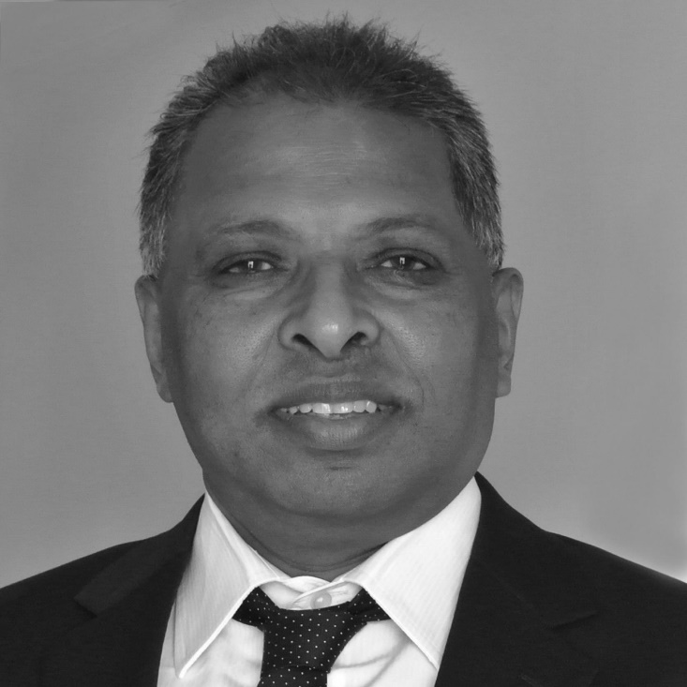
Som Naidu is currently Pro-Vice Chancellor Flexible Learning and Director, Center for Flexible Learning, at the University of the South Pacific. Dr Naidu possesses undergraduate qualifications in Education from the University of Waikato in New Zealand, and graduate qualifications in Educational Technology from Concordia University in Montreal, Canada. A former president of the Open and Distance Learning Association of Australia, Dr Naidu has served as Executive Editor of its journal Distance Education since 1997. In May 2014 the Open University of Sri Lanka awarded Dr Naidu a D.Litt. (Honoris Causa), in recognition of his extensive contribution to the field of open, flexible, distance and e-learning both regionally and internationally.

References
Bates, A. W. (2015). Teaching in a digital age. Vancouver, BC: BCcampus. Retrieved from https://opentextbc.ca/teachinginadigitalage/
Jordan, K. (2015). MOOC completion rates: The data. Retrieved November 23, 2018, from www.katyjordan.com/MOOCproject.html
Kirkpatrick, K. (2018, June). Bringing the internet to the (developing) world. Communications of the ACM, 61(7), 20–21. doi:https://doi.org/10.1145/3213775
Ng, A., & Widom, J. (2014). Origins of the modern MOOC (xMOOC). Retrieved November 23, 2018, from http://robotics.stanford.edu/~ang/papers/mooc14-OriginsOfModernMOOC.pdf
Omoeva, C., Moussa, W., & Gale, C. (2018). The economic costs of educational inequality in developing countries. In I. BenDavid-Hadar (Ed.), Education finance, equality, and equity (pp. 181–217). Cham: Springer International Publishing.
Prabhakar, T. V., Shukla, S., & Shukla, G. (2016). Mobi-MOOCs: A simple and effective way to deliver educational content. Commonwealth of Learning (COL). Retrieved from https://oerknowledgecloud.org/sites/oerknowledgecloud.org/files/PDF%20(7).pdf
Rodriguez, C. O. (2012). MOOCs and the AI-Stanford like courses: Two successful and distinct course formats for massive open online courses (p. 1-13). European Journal of Open, Distance and E-Learning, http://www.eurodl.org/?article=516.
SDG Compass. (2015). The guide for business action on the SDGs. Retrieved from https://sdgcompass.org/wp-content/uploads/2015/12/019104_SDG_Compass_Guide_2015.pdf
Siemens, G. (2008–2012). MOOCs [Series of blog posts]. Connectivism. Retrieved from www.connectivism.ca/?s=MOOC
Sokolik, M. (2014). What constitutes an effective language MOOC? Language MOOCs: Providing Learning, Transcending Boundaries, 16–32. https://doi.org/10.2478/9783110420067.2
Yousef, A. M. F., Chatti, M. A., Schoroeder, U., Wosnitza, M., & Jacobs, H, et al. (2014). MOOCs: A review of the state-of-the-art. Proceedings of 6th International Conference on Computer Supported Education – CSEDU 2014. Barcelona, Spain.

