LEST WE FORGET
Commemorating the 70th Anniversary of the Bombing of Hiroshima and Nagasaki

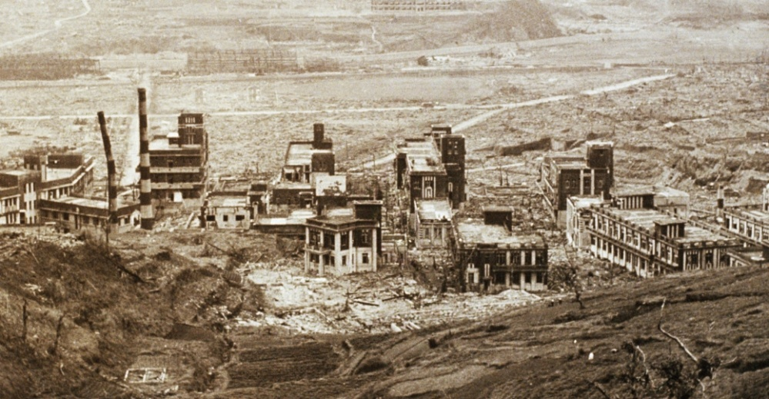
http://cdn.history.com/sites/2/2014/01/nagasaki-buildings-after-bomb-P.jpeg

Announcing a Panel Event
Sponsored by
School of Government Development and International Affairs (SGDIA) &
School of Social Sciences (History Programme)

TO COMMEMORATE THE 70th ANNIVERSARY OF THE TRAGIC BOMBING OF HIROSHIMA AND NAGASAKI AND RECALL THE PACIFIC ‘S ANTI NUCLEAR HISTORY
DATE: Thursday 6th August
ROOM: FBE Postgraduate Lecture Theatre (USP)
TIME: 2-3:30pm
SPEAKERS:
SANDRA TARTE (CHAIR)
RYOTA NISHINO
SULIANA SIWATIBAU
VIJAY NAIDU
CLAIRE SLATTER
GREG FRY
VANESSA GRIFFEN
Contact Andreea Torre for any further information: torre_a@usp.ac.fj

