Teachers as Designers: At the Confluence of Technology, Pedagogy and OER
Shironica P. Karunanayaka¹ and Som Naidu²
¹The Open University of Sri Lanka, ²The University of the South Pacific
¹shironica.k@gmail.com ²sommnaidu@gmail.com

Introduction

Technology-enhanced teaching and learning is an outcome of the integration of technology and pedagogy. While technology integration can augment the teaching-learning process, teachers’ willingness and their capacity to use technology and pedagogy creatively and meaningfully is crucial to student learning. For effective technology integration, teachers require specific knowledge on three broad knowledge bases - technology, pedagogy, and content, and their complex inter-relationships, as described in the Technological, Pedagogical and Content Knowledge (TPACK) framework (Mishra & Koehler, 2006). Teachers also require competencies in putting into practice this synthesized knowledge, when designing learning experiences for their students.

While TPACK offers a good conceptual framework about the interplay of content, technological and pedagogical knowledge, the synergy of technology and pedagogy in the teaching-learning process calls for serious attention to the design of learning experiences in teacher professional development programmes. This needs careful thought about the intersections of subject matter content, pedagogy and technological affordances, and what design strategies would support them to develop the required competencies (Naidu, 2016).

This chapter reports on the experiences of teacher educators’ in the integration of content, pedagogy and technology, during an OER-integrated online professional development course. A scenario-based learning (SBL) approach (Naidu, 2010; 2006) was adopted in this course, within which participants assumed the role of ‘teachers as designers’ of productive student learning experiences.

Review of Literature and the Conceptual Framework

TPACK Framework
The integration of technology into teaching and learning requires teachers to develop a clear understanding of how technology relates to the pedagogy and content. This comprises a complex interaction of three bodies of knowledge, namely content, pedagogy, and technology (Koehler & Mishra, 2009). Content knowledge (CK) or knowledge of subject matter, and pedagogical knowledge (PK), or knowledge of how to teach the subject matter, are basic requirements for any teacher, as explained by the notion of PCK (Shulman, 1986). With the addition of knowledge about technology (TK) to this, the TPACK framework illustrates how these three broad knowledge bases – technology, pedagogy and content intersect to create ‘several forms of new knowledge’ (Mishra & Koehler, 2006) (See Figure 1).
Figure 1: TPACK Framework (Source: http://tpack.org, 2012)

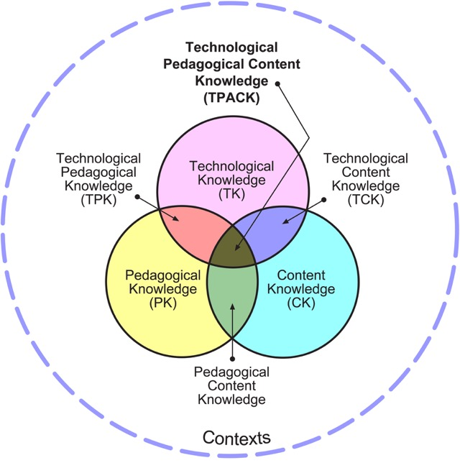
Figure 1: TPACK Framework (Source: http://tpack.org, 2012)

Figure 1 captures these different knowledge types as explained below, which will support the development of a composite skill set needed by teachers for successful integration of technology:
CK – Subject matter (concepts, theories, ideas, frameworks, approaches)
PK – Learning and teaching methodologies (processes, practices, strategies)
TK – Technologies (tools, resources, hardware, software and their affordances)
PCK – Transformation or adaptation of subject matter in ways to enhance their understanding.
TCK – Affordances of technology to represent content in ways to enhance their understanding.
TPK – Pedagogical affordances and constraints of technologies.
TPCK –Knowledge on all the above, how technology can be shaped to meet the pedagogical needs to teach the required subject matter.

The TPACK framework has been extensively adopted in the design of teacher professional development programmes, especially in ICT-integrated teaching and learning (Chai, Koh, & Tsai, 2013; Hofer, Bell, & Bull, 2015; Voogt & McKenney, 2017 ). Its emphasis is on the use of appropriate approaches for developing these connected contextualized knowledge domains. A solid grasp of all of these competencies are essential for the design of productive learning experiences (see Figure 2).

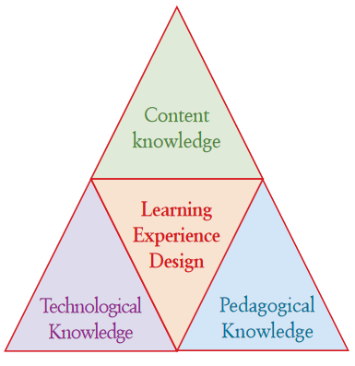
Figure 2: Learning experience design in the synergy of content, technology and pedagogy
(Source: Naidu, 2016)

Learning experience design is about decision-making around the scoping and selection of the subject matter content, its delivery mode and technologies to be used, and the pedagogical principles that would drive the design of the learning experience (Naidu, 2016). When designing teacher professional development programmes, a focus on how to design learning experiences for teachers to develop a clear understanding of the dynamic relationships between content, pedagogy and technology, and apply them in real life situations is essential.

Scenario-based learning
A Scenario-based Learning (SBL) approach was adopted as part of this project in which teachers played out the role of designers of productive learning experiences for their students. SBL is grounded in the principles of situated learning and cognition (Brown, Collins & Duguid, 1989; Cognition and Technology Group at Vanderbilt, 1990; Lave & Wenger, 1991) and it provides a useful framework for designing learning experiences for the development of professional competencies of educators. Designing such constructivist learning experiences involves engaging learners in knowledge construction in authentic, problem-based, challenging and collaborative learning environments, with adequate cognitive, social and contextual support (Duffy & Jonassen, 1991; Jonassen, Peck & Wilson, 1999).

The SBL approach to learning comprises several critical elements. These are, a goal-based learning scenario in which learners assume a key role in the pursuit of a mission, successive learning activities in the form of challenges, and assessment tasks which fulfill the achievement of the desired learning outcomes (Naidu, 2010; 2006; Schank, 1997). When practitioners are situated in such authentic learning scenarios that provide the context, and when they are taken through a sequence of challenging learning and assessment tasks with the support of learning resources which provide the content, it helps them develop new competencies, and build upon their existing professional competencies, enabling the achievement of intended learning outcomes (Naidu, Menon, Gunawardena & Karunanayaka, 2007).

The design and development of productive authentic learning experiences for practitioners using a SBL approach requires careful attention to the intersections of subject matter content, pedagogical approaches and technological affordances (Naidu, 2016). A useful approach to the orchestration of such learning experiences with the appropriate integration of learning resources, preferably OER, that will provide the essential fuel is captured by the learning engine framework (see Figure 3).

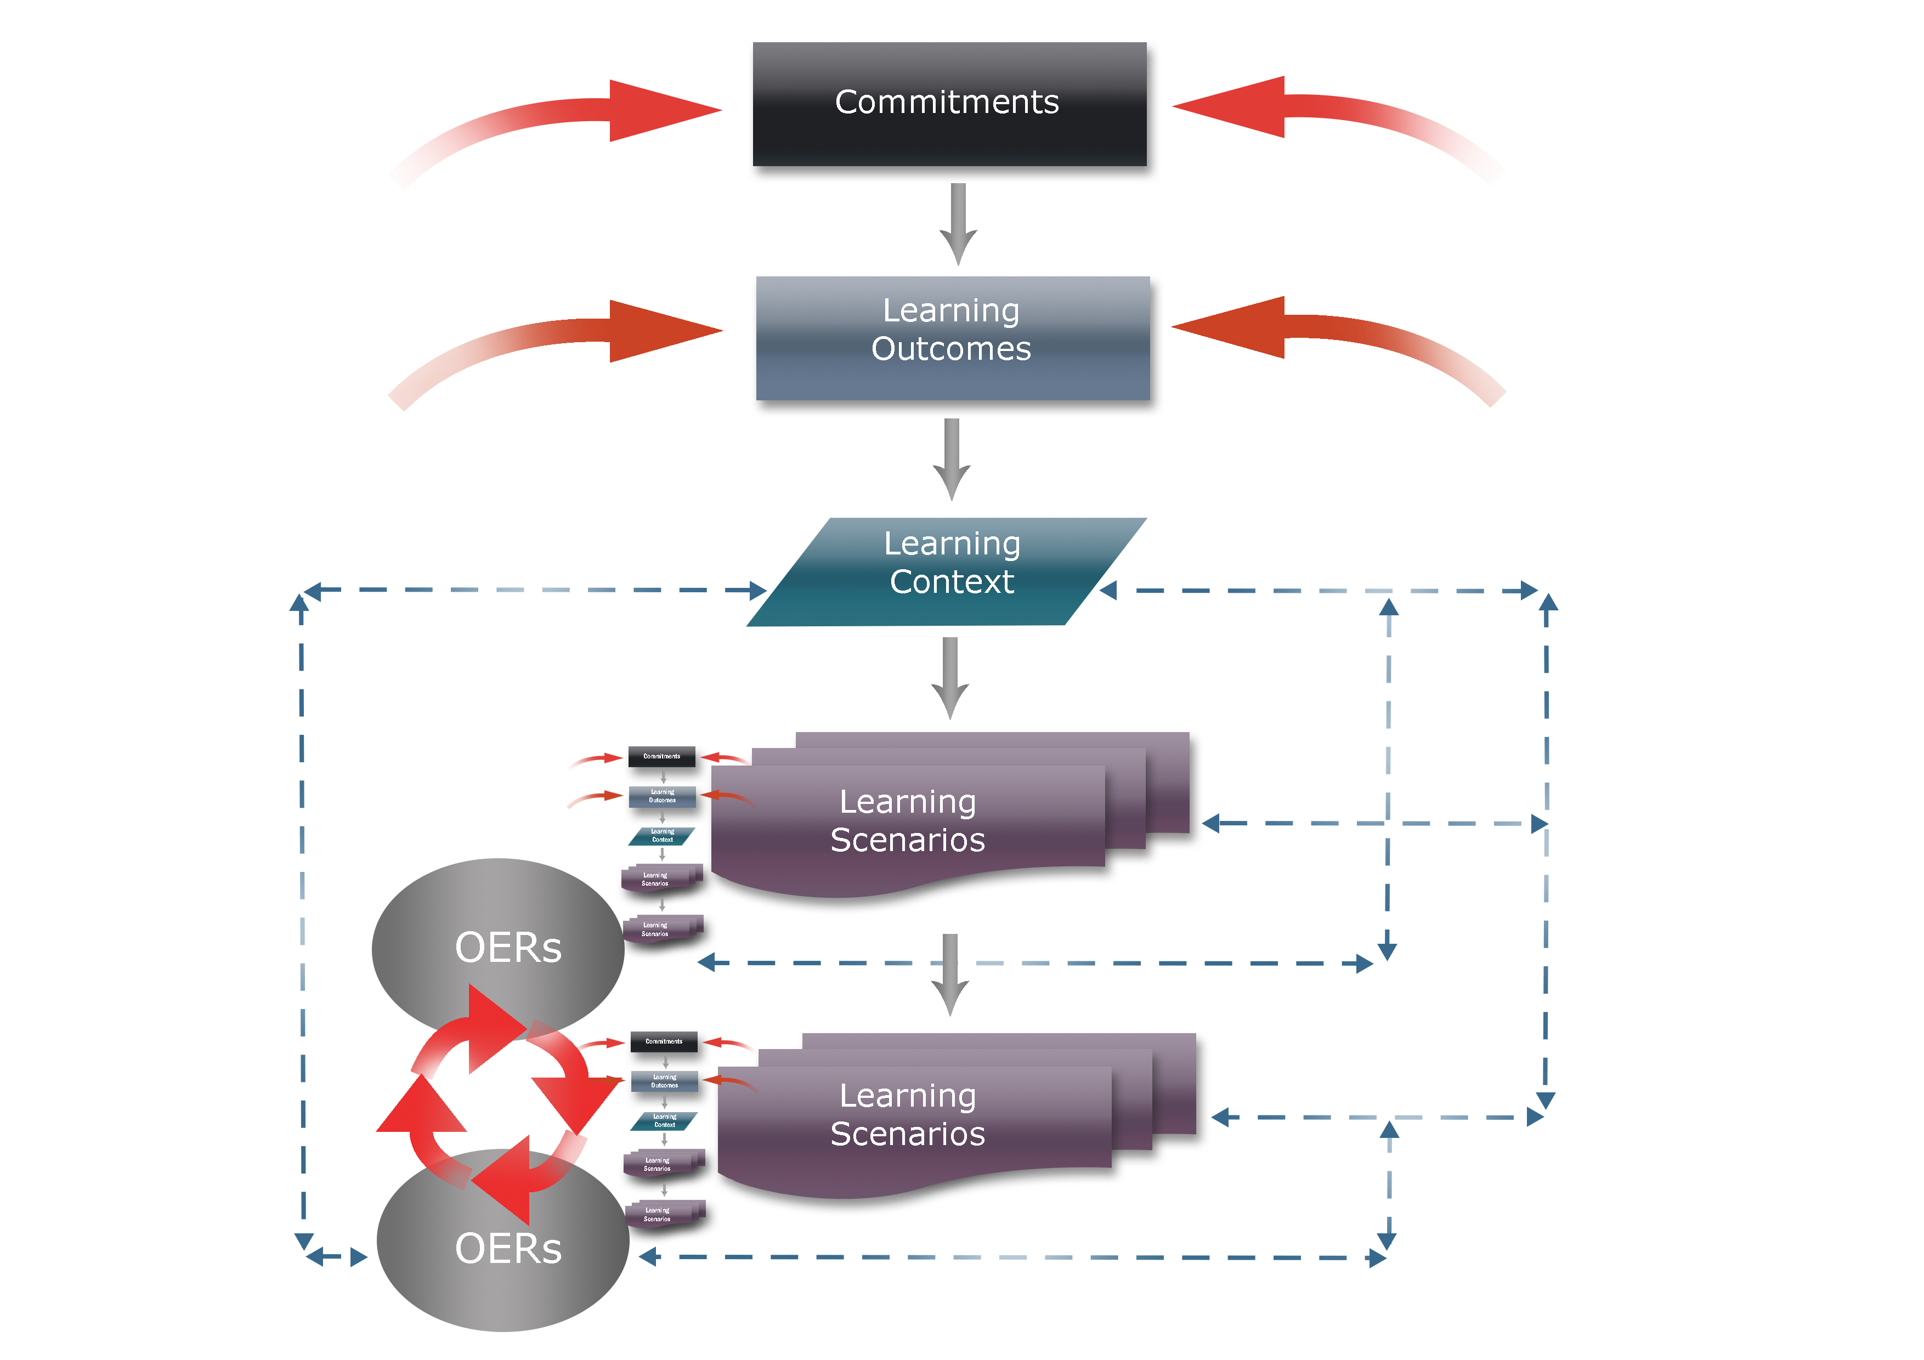
Figure 3: A “Learning Engine” framework to design learning experiences
(Source: Naidu & Karunanayaka, 2014, p. 8)

It comprises a sequence of tasks including: identifying teacher commitments to the learners; developing intended learning outcomes; articulating the learning context; creating learning scenarios, developing relevant learning activities and assessment tasks; and integrating OER in the learning experience as appropriate (see Naidu, & Karunanayaka, 2014).

Role of Teachers as designers in SBL
Teaching is a design science (Laurillard, 2012). Teachers are routinely engaged in the design of learning experiences for their students. To be effective designers of such learning experiences, teachers need not only be masters of the subject matter content, but also able to select the best methods and strategies to teach that content, as well as the most appropriate technological tools to support their teaching. In other words, as learning experience designers, teachers should be able to put into practice different forms of knowledge (TPACK) developed by them when designing learning experiences for their students (Koehler & Mishra, 2005; Koehler, Mishra, Akcaoglu, & Rosenburg, 2016)). In the context of contemporary technology-rich learning environments, this is crucial.

For teachers to function as designers will require the acquisition of core competencies including: gathering information; analysing and diagnosing problems; determining actions; carrying out actions; and evaluating actions, which constitute a dynamic cyclic process (Kirschner, 2015). As design scientists, teachers will need to be reflective practitioners. They will need to move beyond from having the knowledge base to being able to understand and apply knowledge on TEL in authentic situations (Kirschner, 2015).

Professional development programmes for teachers must provide opportunities for them to appreciate the dynamic relationships between content, pedagogy and technology. Situating teachers in unique contexts with authentic learning scenarios, by taking a SBL approach in professional development programmes will engage them in the efficient use of their knowledge on these different elements. When designing such programmes, it is very important to emphasize how teachers integrate technology in their practice, rather than on what they integrate (Mishra & Koehler, 2006). Taking a ‘teachers as designers’ approach (Koehler & Mishra, 2005) within an SBL approach in professional development programmes, has the potential to enable teachers to ‘learn by designing’ (Harel & Papert, 1990), using their synthesized knowledge in relation to content, pedagogy and technology.

The course “Teacher educator as an educational technologist”, an OER-integrated online course (reported here) was designed and developed based on this conceptual framework, with the following research questions formulated to drive this study.

Research Questions:
- What challenges were faced by the educators, in achieving appropriate integration of technology and pedagogy during their learning experience in the OER-integrated online course?
- How and to what extent, the design strategies adopted in the OER-integrated online course supported them to overcome those challenges?
- What are the impacts of the OER-integrated online course on educators in developing their competencies to design technology-enhanced learning experiences for their students?

The Case Study: The Teacher Educator as an Educational Technologist

The course “The Teacher Educator as an Educational Technologist” (TEET) is part of the MA in Teacher Education (International) Programme developed by the Faculty of Education, at the Open University of Sri Lanka (OUSL) during 2003/2004 with the support of Commonwealth of Learning (COL). This course aims at developing professional competencies among teacher educators in the design, development, implementation and evaluation of appropriate educational technologies, using a SBL approach (Karunanayaka & Naidu, 2010). Participants in this course are required to develop a rationale for using educational technologies, design learning experience for their students, select and use appropriate media to develop a prototype of an interactive multimedia learning material, implement it and evaluate its effectiveness.

During 2013/14, the course underwent a significant review and re-designing process, with the intention of providing more effective, efficient and engaging learning experiences to learners, within the SBL pedagogical approach, with a key focus on integration of ICT and OER (Karunanayaka, 2014; Karunanayaka, Fernando, Jayasinghe, De Silva, & Hewapathirana, 2014). The re-designed online course was piloted as a fully online course– ESE4242 (during 2014/15) – English Medium only – (09 students). Later, it was implemented as a Blended Online Course – ESP2242 (during 2016/17) – English (08); Sinhala (25); Tamil (25).

In this case study of the TEET course we discuss how the three elements – pedagogy, content and technology were brought together, with the use of a scenario-based learning (SBL) pedagogical approach; Integration of Open Educational Resources (OER) to provide subject matter content; and an Online Learning Environment (OLE) created in Moodle LMS. Data was collected from three cohorts of participants who followed the TEET course during 2014-2017 using surveys, self-reflections and focus group interviews.

Course Design

We re-designed the TEET course as an OER-integrated online professional development course for teacher educators to support development of their competencies in technology-enhanced teaching and learning. Specific design strategies were adopted to augment the integration of content, technology and pedagogy and to support the participants achieving the intended learning outcomes during their course of study over 24 weeks.

In accordance with the ‘learning engine’ framework (See Figure 3), the course redesign process commenced with identifying the key competency and the learning outcomes expected to be achieved by the participants. The key competency identified was, the ability to create a technology-enhanced learning material, to be achieved by fulfilling the following learning outcomes:
- Identify and analyse strategies to make teaching and learning an effective communication process
- Plan and design a technology-enhanced learning material on a selected topic and select appropriate media to enhance the planned learning experiences
- Create a storyboard for the planned learning material
- Develop the learning material using appropriate software
- Implement and evaluate the learning material and critically reflect on the process of integrating technology in teaching and learning.

Next, we proceeded with identifying the key events, processes and challenges faced in the real life of an expert who has already accomplished these outcomes, and accordingly develop learning scenarios, learning activities and assessment tasks to be completed by the participants within the context of the scenarios.

The key course design aspects of the TEET course comprised the following:
- SBL - Scenario-based learning (SBL) pedagogical design, situating the participants in authentic learning scenarios, enabling them to build up new competencies upon their existing professional competencies, by engaging in a series of challenging tasks leading to the achievement of intended learning outcomes (within a “learning engine” design framework, Figure 3).
- OER – Open Educational Resources (OER) were integrated as the key learning resources providing the subject matter content to support the participants to engage in their learning and assessment activities.
- OLE – An Online Learning Environment (OLE) created in Moodle LMS provided the technological affordances, supporting their learning experience.

A ‘teachers as designers’ approach was taken in the learning experience created for the participants, compelling these educators to use and to put into practice their synthesized knowledge in relation to content, pedagogy and technology to design appropriate learning experiences for their students. As the learning outcomes indicate, the participants of the TEET course were required to engage in a series of tasks to design learning experience for their own students, select and use appropriate media to develop a prototype of an interactive multimedia learning material, implement it and evaluate its effectiveness. The specific activities designed in relation to each learning scenario, aligned with the learning outcomes, are summarized in Table 1.

Table 1: Activities designed in the TEET course to support participants to function as ‘designers’
Learning Scenario | Purpose | Activities
A: “What shall I do?” | L.O.1: Identify and analyse strategies to make teaching and learning an effective communication process  - Building upon existing knowledge  - Familiarising with SBL;OER;OLE | Reflect on the methods and techniques of teaching (Online Quiz)
B: “A Trigger!” |  | Identify effective communication strategies for teaching-learning process (Online quiz)
C: “Facing the challenge…” | L.O.2: Plan and design a technology-enhanced learning material on a selected topic and select appropriate media to enhance the planned learning experiences  - Analyse requirements  - Design learning experiences | - Select a topic/subtopic from any subject you teach  - Analyse target group, subject matter content  - State the learning outcomes  - Plan the learning experiences  - Select appropriate media for each learning experience, with justification  - Create a Concept Map depicting all the above  - Engage in an online discussion
D: “Moving forward…” | L.O.3: Create a storyboard for the planned learning material  - Design learning experiences  - Develop the learning material | - Organize the learning events and prepare a flow chart  - Design learning experiences  - Organize integration of media  - Decide on the navigation structure  - Create a detailed Storyboard depicting the above  - Engage in an online discussion
E: “On track…” | L.O.4: Develop the learning material using appropriate software  - Develop the learning material | 1. Select appropriate software to develop the technology-enhanced learning material  2. Develop the learning material using the selected software -Hands-on Workshop  3. Prepare a report on the process of developing the technology-enhanced learning material  4. Engage in an online discussion
F: “Reaching the goal!” | L.O.5: Implement and evaluate the learning material and critically reflect on the process of integrating technology in teaching and learning  - Implement - Pilot the learning material  - Evaluate the learning material | 1. Develop appropriate instruments to evaluate the learning material  2. Implement the learning material with a selected student group  3. Evaluate the learning material  4. Prepare and submit an evaluation report with evidence  5. Write a reflection on the whole process you went through  6. Make an Oral Presentation  7. Engage in an online discussion

Analysis and Discussion

As indicated in Table 1, the participants were taken through the learning experience in a progressive manner imagining “teachers as designers” of the learning experience for their students with the integration of pedagogy, content and technology. The learning scenarios served as the context to situate, activate and motivate the participants to engage in the learning activities, in relation to each learning outcome. The scenarios were linked in a progressive storyline, enabling participants to move from known to unknown – initially reflecting on already known facts and principles, and then building new knowledge upon their existing knowledge. For instance, scenarios A and B focused on prompting the participants to recap their prior knowledge on methods and strategies related to teaching, learning as a communication process, which was a requirement to progress with the remaining scenarios.

The sequential learning activities - both offline and online, gave an opportunity for the participants to ‘learn by doing’, developing the required skills during the process, supported with selected OER as learning resources at relevant points. From scenario C onwards, the educators functioned as ‘designers’. They actively engaged in a series of linked tasks that involved design, development, implementation and evaluation of a TEL material. The course design strategies enabled development of relevant knowledge in the three key domains according to TPACK (CK, PK and TK) and their intersects, as well as skill development in the practical application of those among the participants, ensuring their achievement of intended learning outcomes (see Table 2).

Table 2: Alignment of tasks in the learning experience design of TEET course with TPACK
TPACK | Requirement (Ability to…) | Specific Tasks
CK | Select appropriate subject matter content, scoping, sequencing, constructive alignment | Formulating learning outcomes  Concept mapping with constructive alignment  Flow charting
PK | Select and use appropriate teaching-learning methods and strategies to meet the purpose and needs of the target group | Self-assessment quiz (online) on prior knowledge  Concept mapping  Storyboarding
TK | Select and use appropriate technological tools and resources to develop a TEL material for the target group (their students) | Use of hardware (computer skills)  Selection of software tools  Selection of media resources; OER  Use of Internet and LMS
PCK | Design the learning experiences for their students by adapting and presenting content in multiple ways | Concept mapping  Learning Experience Design of the TEL material
TCK | Select appropriate media elements to represent the content in diverse ways (Audio/Video/Animations…) | Concept mapping  Storyboarding  Media selection report
TPK | Select and integrate appropriate technology tools and media elements to support the learning of their students | Storyboarding  Media selection report  Creation of a TEL material
TPCK | Create a TEL material on a selected topic to support learning of their students, implement and evaluate it. | Creation of a TEL material  Evaluation report  Oral presentation

The effects of this challenging process, as captured by the participants’ reflections, are summarized and presented in Table 3, under the three key elements – Pedagogy (SBL); Content (OER) and Technology (OLE), categorized against the Challenges (C), Support (S) and Impacts (I).

Table 3: The key effects of the “teachers as designers” approach adopted in the TEET course
Element | Challenges (C) | Support (S) | Impacts (I)
Pedagogy  (SBL) | Novelty  Changing mindsets  Workload  Time management | Authentic scenarios  Clear, systematic guidance  Interactive sessions  Step-by-step, simple to complex progression | Critical thinking  Creative learning  Self-regulated learning  Reflective learning
Content  (OER) | Novelty  Self-study  Limited English language skills  Time constraints | Essential/Additional resources  Relevant; Specific  Variety; Multimedia  Compulsion | Motivation  Usefulness  Satisfaction
Technology  (OLE) | Novelty  Reluctance  Limited technical skills  Technical issues | Structured environment  Instructor guidance  Collaborative peer work  Discussion forum feedback | Excitement  Confidence  Pride

Analysis of data revealed the effect of seeing “teachers as designers” on the participants, under the three key elements of their learning experience – SBL; OER & OLE, in terms of the challenges they faced, support received and impacts of the process.

Challenges
The participants found this whole experience novel and highly challenging. Coping with three novel aspects of the process – SBL, OER and OLE, at the same time posed a great challenge to them.

The following quotes reveal some of the key challenges faced by them:
…I got all these (technological) experiences for the first time during this course…I did not have any computer knowledge…also I faced difficulties in getting access to resources… It was very challenging for me…I wondered whether I could integrate technology in my teaching, and even thought I might have to give-up…
…Initially I faced some problems because I didn’t have a PC…I felt ashamed because in this technology era…so I decided to buy a laptop…
…This was the subject where I felt very uncomfortable…Everything was new…concept mapping, storyboarding, using software, online discussions…limited technical knowledge and English language skills…I faced severe issues coping with these…
…I had a dream of preparing a very nice self-learning multimedia package…As I had poor IT knowledge, every time when I tried I failed…Though the learning package has a lot of weaknesses I am happy that I could develop a TEL package for my student teachers…
…I was a very backward learner…At my age, it was exhausting…Actually I didn’t like technology…I was under very much pressure…But you raised me up…now I can work with technology…

Managing the complex interactions among content, pedagogy, and technology was hindered by several limitations. Educators’ established conventional pedagogical practices, limited technical skills, limited knowledge of the English language, limited resources, technical and internet connectivity problems and time constraints were some prevailing issues identified.

Support
Despite the challenges faced, the participants managed to pursue in their journey, with the support of various design strategies adopted in the OER-integrated online course, as revealed below.

Situating the educators in authentic learning scenarios supported them engage with real life challenging tasks:
…The learning scenarios were interesting and realistic…So it was easy to link them with our work practically…

Provision of OER as learning resources was found to be useful in media selection:
…The OERs were very supportive for me to select different media such as pictures, animations, audio clips and video clips to integrate…to make the learning experience more attractive…

All participants claimed that the systematic guidance and continuous scaffolding provided throughout the learning process using specific strategies have been extremely helpful and encouraging:
…I realized that proper storyboarding will make the TEL material creation easier…
…The workshop sessions were very useful to get the hands-on experience in using the software to create the TEL material….
…It was very supportive that we had done the concept mapping, flow charting and media selection before creating the TEL material…I realized the importance of pre-preparation…

Using the OLE allowed close interactions with the peers and course instructors which also found to be a very supportive aspect for educators to overcome the challenges faced. ​
…The online discussions were very useful…I could solve many technical problems that arose with using new software, through discussions with my peers…
…I am happy to say…I helped most of the peers to develop their package. Their feedback motivated me a lot…

Interestingly, many participants revealed that in addition to instructor and peer support, the support received from their family members in various ways was tremendous to cope up with the stress.

Impacts
During the course of study of TEET, the participant teacher educators have become empowered professionals with confidence to design, develop and implement technology-enhanced learning in their own contexts.

They have become ‘change agents’, as revealed by following excerpts:
…I’ve never had this sort of an experience before…I got a very systematic experience in creating TEL materials…I feel this can be creatively used in the teaching-learning process of my student teachers as well as in the school children’s learning…
…This was a turning point in my life. It made significant changes in me…Now I conduct my teacher-training programmes very effectively…
…Got a great experience…I believe I can do a big change now…With this experience I hope to take maximum effort to support teachers and students…

Further, this process has impacted on increasing their motivation, satisfaction, self-confidence and pride.
…This is a fantastic subject…It has been a high-speed journey…I am proud of the TEL material I created amid various difficulties…
…This course helped developing excellent skills…I got competent in multi-tasking…increased my self-confidence, professional self-esteem and professional proficiency…

It was heartening to observe that many educators who initially had minimal computer skills were motivated to purchase their own laptops and develop their skills and successfully complete the tasks with pride.

Evidently, this learning experience has promoted self-regulated learning, collaborative learning, and reflective practice among educators through the development of their key competency – “Ability to create a technology-enhanced learning material”.

Conclusions and Implications

Engagement in the OER-integrated online course with the SBL design has impacted educators in terms of enhanced competencies, confidence, satisfaction and motivation to create technology-enhanced learning materials. The ‘teachers as designers’ approach enabled educators to use their synthesized knowledge in relation to content, pedagogy and technology to put it into practice in the design of appropriate technology-enhanced learning experiences ​for their own students, making this whole process a meaningful learning experience for them. Without meticulous design of how these will work in synergy, neither technology, nor the pedagogy would be as engaging, effective or efficient.

References
Brown, J. S., Collins, A., & Duguid, P. (1989). Situated cognition and the culture of learning. Educational Researcher, 18 (1), 32-41.
Chai, C.-S., Koh, J. H.-L., & Tsai, C.-C. (2013). A Review of Technological Pedagogical Content Knowledge. Educational Technology & Society, 16 (2), 31–51 Retrieved from http://www.ifets.info/journals/16_2/4.pdf
Cognition and Technology Group at Vanderbilt, (1990). Anchored instruction and its relationship to situated cognition, Educational Researcher, 19(6), 2–10.
Duffy, T. M., & Jonassen, D. H. (1991). Constructivism: New implications for instructional technology? Educational Technology, 31 (5), 7-12.
Harel, I. & Papert, S. (1990). Software design as a learning environment. Interactive Learning Environments, 1(1). 1-32
Hofer, M., Bell, L., & Bull, G. (2015). Practitioner’s Guide to Technology Pedagogy and Content Knowledge (TPACK). North Carolina: AACE. Retrieved from https://www.learntechlib.org/p/151881
Jonassen, D., Peck, K., & Wilson, B. (1999), Learning with technology: A constructivist perspective. Upper Saddle River, New Jersey, Merrill.
Karunanayaka, S. & Naidu, S. (2010). Developing Professional Competencies of Teacher Educators in the use of Educational Technology, with Scenario-based Learning In W. Kinuthia & S. Marshall (Eds.) Cases ‘n’ Places: Global Cases in Educational Technology, (pp. 123-132). Information Age Publishing, USA.
Karunanayaka, S. (2014). Open University of Sri Lanka –Integrating OER in a Teacher Education Course. In S. Naidu & S. Mishra (Eds). Case Studies on OER-based eLearning. New Delhi:CEMCA. (pp 1-10). Retrieved from http://oasis.col.org/bitstream/handle/11599/561/CaseStudies_OER-based_eLearning.pdf
Karunanayaka, S. Fernando, C., Jayasinghe, S., De Silva, V., & Hewapathirana, C. (2014). Change through Technology: A Journey. In S. Karunanayaka & S. Naidu (Eds). Integrating OER in Educational Practice : Practitioner Stories. The Open University of Sri Lanka. (pp. 93-122). Retrieved from http://www.ou.ac.lk/home/images/OUSL/publications/intergratingOERinEducationalPractice.pdf
Kirschner, P. A. (2015). Do we need teachers as designers of technology-enhanced learning? Instructional Science. 43. 304-322 doi: 10.1007/s11251-015-9346-9
Koehler, M. J., & Mishra, P. (2005). Teachers learning technology by designing. Journal of Computing in Teacher Education, 21(3), 94-102.
Koehler, M. J., & Mishra, P. (2009). What is technological pedagogical content knowledge? Contemporary Issues in Technology and Teacher Education, 9(1), 60-70.
Koehler, M. J., Mishra, P., Akcaoglu, M., & Rosenburg, J.M. (2016). The technological pedagogical content knowledge framework for teachers and teacher educators In M.N. Panigrahi (Ed.). ICT integrated teacher education. (pp. 20-30). New Delhi: CEMCA
Laurillard, D. (2012). Teaching as a design science: Building pedagogical patterns for learning and technology. New York: Routledge
Lave, J., & Wenger, E. (1991). Situated Learning: Legitimate peripheral participation, Cambridge University Press: New York.
Mishra, P., & Koehler, M. J. (2006). Technological Pedagogical Content Knowledge: A framework for teacher knowledge. Teachers College Record, 108(6), 1017-1054. doi: 10.1111/j.1467- 9620.2006.00684.x.
Naidu, S. & Karunanayaka, S. (2014). Engines of Education: Integrating OER in Learning and Teaching. In S. Karunanayaka & S. Naidu (Eds). Integrating OER in Educational Practice: Practitioner Stories. The Open University of Sri Lanka. (pp 3-22). Retrieved from http://www.ou.ac.lk/home/images/OUSL/publications/intergratingOERinEducationalPractice.pdf
Naidu, S. (2006). E-Learning, A guidebook of principles, procedures and practices, Commonwealth Educational Media Centre for Asia, Retrieved from http://cemca.org.in/ckfinder/userfiles/files/elearning_ guidebook.pdf
Naidu, S. (2010). Using scenario-based learning to promote situated learning and develop professional knowledge. In E.P. Errington (Ed.). Preparing graduates for the professions using scenario-based learning (pp. 39-49). Brisbane: Post Pressed
Naidu, S. (2016). Technology, education and design: The sciences of the artificial. In M.N. Panigrahi (Ed.). ICT integrated teacher education. (pp. 20-30). New Delhi: CEMCA.
Naidu, S., Menon, M., Gunawardena, C., Lekamge, D., & Karunanayaka, S. (2007). How can scenario-based learning engender and promote reflective practice in online and distance education. In M. Spector (Eds.), Finding Your Online Voice: Stories Told by Experienced Online Educators (pp. 53-72), New Jersey: Lawrence Erlbaum.
Schank, R. (1997). Virtual learning: A revolutionary approach to building a highly skilled workforce. New York: McGraw-Hill.
Shulman, L.S. (1986). Those who understand: Knowledge growth in teaching. Educational Researcher, 15(2), 4-14.
Voogt, J. & McKenney, S. (2017). TPACK in teacher education: are we preparing teachers to use technology for early literacy? Technology, Pedagogy and Education. 26 (1). 69-83. doi: 10.1080/1475939X.2016.1174730

