Abstract:
The predominant approach to teaching is largely content-centric with a focus on the understanding of the subject matter and not so much on its application. The first generation of MOOCs adopted this same approach and failed to live up to their expectations for optimizing the affordances of communications technology. There is a better way to design MOOCs, and this alternative approach is about starting with the learning context and asking what is it that we want the learners to be able to do, and what are their learning outcomes. And then designing a learning experience that will be able to offer an internship to learners in solving real-world problems as part of the learning process.. Such an approach requires a radical paradigm shift in the design of MOOCs. But this kind of shift in perceptions and perspectives about teaching and learning will not readily occur without careful redesign of conventional choreographies. As a response, this chapter describes the development of this redesign process that is based on thinking around general systems theory.

Running Head Right-hand: PERSPECTIVES ABOUT THE DESIGN OF MOOCS
Running Head Left-hand: Som Naidu and Shironica P. Karunanayaka

7

Orchestrating Shifts in Perspectives and Practices About the Design of MOOCs
Som Naidu and Shironica P. Karunanayaka

Introduction
Generally, when asked to teach something, instructors begin with the subject matter content that needs to be taught. They start to research the topic, how others have approached its teaching, and plan to teach it from simple to complex concepts. This constitutes a content-centric approach designed to teach learners the subject matter content. When that is done, and even if their performance on assessments indicate that students know all the content, they are often left asking – so now what? Sure they might know many facts, principles and procedures, but given a situation or specific problem to solve, they are unable to apply their content knowledge to solve the problem in that setting, because they have not learned how to do so. In effect their knowledge is inert (see Brown, Collins, & Duguid, 1989). As a result, many students are left to muddle through their work and learn by direct experience how to apply their knowledge only after they have entered the work force.
The first generation of MOOCs that came out of the developed world, many from Ivy League institutions, replicated this content-centric approach to learning and teaching (Romiszowski, 2013). So, despite their widely vaunted promises, MOOCs, including those purported to be based on constructivist principles, have so far failed to live up to their expectations of opening up and democratizing learning (Naidu, 2013). In fact most of them fail to meet the minimalist expectations of good teaching and learning practices. Most of them demonstrate models of conventional lecture-based practices with limited, or no interaction between students and staff, and among students, disregarding existing good principles of learning and teaching (Romiszowski, 2013. They continue to be developed with a highly content-centric focus, mostly using video-based lectures, promoting an outdated model of content and teacher-centered learning.
There is a better way to design MOOCs. This much better approach promises to teach the learner the subject matter, but also how to apply that subject matter in authentic settings, such that at the end of this learning experience, the student has both, subject matter knowledge and the capacity to apply that knowledge in real-world settings. This is not the same as workplace-based learning or work-integrated learning which requires learners to be placed in the workplace for periods of internship. This alternative approach is about starting with the context and not the content, and asking what is it that we want our learners to be able to do, what are our commitments to them, and what are their learning outcomes. And from there, designing a learning experience that will be able to offer that internship in solving real-world problems as part of their learning process, and not after it.
These are the same questions that we would, and should, ask in the design and development of any effective, efficient and engaging learning and teaching experience (see Merrill, 2002; Naidu, 2010). We have known that this works, and that learning and teaching is most effective, efficient and engaging when:
1. Teachers and learners are clear about the learning outcomes;
2. Learning is situated within a meaningful context and within the culture and the community in which learners live and work;
3. Learners are engaged in pursuing and solving meaningful and real-world challenges and problems, and where they have opportunities to work on a variety of problems and tasks of increasing complexity with timely and useful feedback;
4. The learning activities in these learning situations are clearly articulated and explicitly linked to knowledge and skills already mastered;
5. Learners, while working on learning situations, are required to think for themselves by reflecting in, and upon their actions and regulating their own performance;
6. The development of understanding is promoted as a social process with learners acting upon authentic situations in groups and with dialogue, discussion and debate;
7. The assessment of learning outcomes is closely aligned with the learning context;
8. The assessment of learning outcomes is linked to meaningful problems and tasks, and aimed at helping students further develop their knowledge, skills and problem-solving abilities; and
9. The assessment of learning outcomes is designed to develop self-regulatory and meta-cognitive skills.

Orchestrating Shifts in Perspectives About MOOC Design
This approach comprises a radical shift in thinking about the design of MOOCs and it involves a fundamental rethink of our approach to the design of learning and teaching experiences. But this kind of shift in perceptions and perspectives about teaching and learning generally, and MOOCs in particular, does not and will not happen easily without careful rethinking. It requires a great deal of structure and guidance and orchestration of that process.
The orchestration of such shifts in mindsets of MOOC developers is a creative process. It is also a process that is based on well-established principles of learning and teaching (Naidu & Karunanayaka, 2014). This chapter describes a model for the application of this process that is based on thinking around viable systems and general systems theory (see Figure 7.1). This process draws on thinking around how viable systems work to propose an engine for the design of the learning and teaching experience, guiding teachers and designers to start where the learner is, and not where the content is at. In this chapter, we describe this framework and its application to shift the perceptions and practices of MOOC developers. We do this with reference to the design and development of a suite of MOOCs for continuing professional development (CPD) on the adoption of open educational resources (OER) and open educational practices (OEP) by practitioners in the South Asian region foremost, but internationally as well.
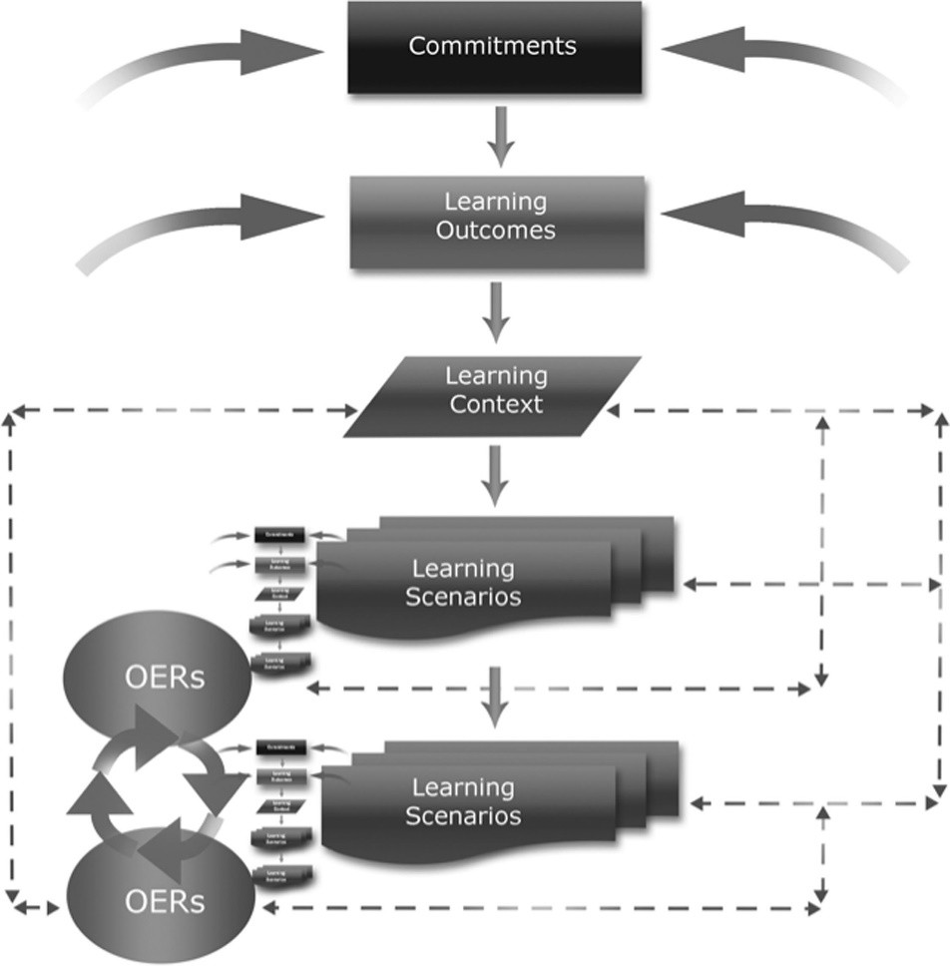
Figure 7.1 The “Learning Engine”
Source: (Naidu & Karunanayaka, 2014, p. 8).

Design of CPD MOOCs on OER and OEP
This suite of CPD MOOCs has been developed at the Open University of Sri Lanka (OUSL) with the sponsorship of the Commonwealth Educational Media Center for Asia (CEMCA) in New Delhi. The goal of this initiative is to raise awareness on the potentials of OER and OEP among practitioners, from any field of study.
This whole initiative comprises four CPD MOOCs that enable participants to solve authentic and real-world problems and issues that they are likely to be facing in their workplace, in relation to adopting OER and OEP. A defining characteristic of these MOOCs is their unique scenario-based design. Learning scenarios have been carefully crafted to reflect the kinds of questions, issues and challenges that practitioners are likely to be facing in their environments with the adoption and integration of OER. We begin with making clear our commitments to students, as we should, in the design of any learning and teaching transaction.

Our Commitments
We commit to making clear to our learners their learning outcomes, the learning context and learning activities, assessment tasks and resources to which they will require access to support them to achieve the learning outcomes. In order to accomplish this, we place learners in real-life-like situations where they are confronted with real-world issues, and ask them to resolve these issues, and not simply define concepts or principles. To be able to address the challenges with which they are confronted, they will need access to subject matter knowledge and we will provide them access to this content.
The following sections of this chapter serve as a window to our design of the learning experiences to meet our commitments to the learners. For a more detailed look at our design architecture, it’s best that you look at the MOOCs themselves at www.ou.ac.lk/apps/mooc/ which are housed at the Open University of Sri Lanka.
Learning scenario
‘Smart HR Institute’ is an organization that conducts staff development programs to assist a variety of organizations in enhancing the skills of their staff. The costs of purchasing or developing resource materials for these programs are becoming an increasing concern to the management and the staff. The program is about to begin next month so there is limited time to update the existing material. The feedback received from participants of the previous training program reveal issues in relation to the quality of some of the materials, including unrelated and outdated information and copyright violations. The program team is confronted with the problem of how these issues could be addressed within the stipulated time period and the limited budget available, and a meeting has been convened to discuss this real-world challenge.
The video shows a meeting in progress in which various options are proffered along with the exploration of the potentials of OER. However, since few participants are likely to be familiar with this concept, as is currently the case more generally, they decide to explore the potential of OER for their purpose. The challenge for the learner then is to explore options and propose a robust solution for a way forward at the next program committee meeting. This task involves learning about OER, and not just learning it for oneself, but representing the key and related concepts and helping others to understand it as well by engaging them in a discussion of it. This then also serves as an assessment activity for this segment of the MOOC.
What is different about this MOOC is that it avoids using video primarily as a presentation tool to present subject matter content to learners. Instead our design uses video to situate learners in the learning context and requires them to engage with the content and see the point of doing so.
The second MOOC adopts the same strategy, and takes the learner on to the next logical step. Now that they have some understanding of OER, the natural follow-on question is, where I can find these kinds of resources and how I will be able to ascertain their quality and suitability for my purpose. A short video segment is used to highlight the challenges faced in searching OER and evaluating its fitness for purpose. Various suggestions are proffered including working with librarians. The lesson here is for learners to be able to learn how to figure out solutions for themselves as opposed to being told what a solution might look like. The task requires proposing strategies for searching OER and how to evaluate their quality.
Now that the learners have an understanding of OER, where and how to find them and ascertain their quality and fitness for purpose, the next logical question is how one can adapt these if there is a need to do so, as well as how one can create their own OERs and share with others. The third MOOC in this suite of MOOCs helps participants with these issues.
Learning scenario
The National Teacher Training College (NTTC) has recently taken a policy decision to use only OER as resource materials in the development of their training modules, and also to release those with the Open License – CC BY-SA. Instructors in NTTC are increasingly using OER in their day-to-day teaching practices, and are currently in the process of preparing new training modules integrating OER for their next intake. However, the Head/Academic Affairs is very concerned about the delay in getting this task completed by the staff within the scheduled time-frame. He noticed that even though the staff has been made aware of different open licensing types in OER permitting them to reuse, revise and remix, most of the time the tendency was only to reuse existing OER as is. He sends an email to the instructors advising them not only to consider reusing available OER, but also to adapt existing OER by revising and remixing, and/or to create new materials as OER to meet different purposes and specific needs.
In the video segment, instructors at NTTC are seen discussing their experience with the task in hand, and about the challenges in being able to find an OER that meets their needs. A common issue emerging is that even though they are able to find a number of relevant OER, many of these resources do not exactly suit their specific purposes and context. Can they revise and remix OER, and if so, then how? What will one need in order to be able to revise an open educational resource? The next task requires learners to engage with issues around revising and remixing of OER and the need for releasing it under similar conditions.
The final MOOC in this suite of four MOOCs addresses the question of the integration of OER in learning and teaching. This is a critical issue because we believe that how a learning resource is licensed cannot influence the learning outcomes one way or another. What does influence the achievement of learning outcomes is how a learning resource is integrated into a learning and teaching transaction (Naidu, 2017; Karunanayaka & Naidu, 2014, 2017). So, in this fourth MOOC, participants are required to demonstrate their competency in integrating OER in their professional practices.
Learning scenario
There is a growing interest in the Western University of Sri Lanka to progress with adopting innovative open practices in teaching and learning. It has recently established an institutional policy on OER. The Vice Chancellor of the University is very keen to take measures in facilitating this transition towards open educational practices (OEP) at the institutional level. The University has recently received an opportunity to get financial support from an international funding agency, to develop innovative teaching-learning practices with OER integration too. However, changing thinking and practices of the academic staff members is very challenging. A majority of staff members are happy to be in their comfort zone maintaining status quo, and reluctant to change from their conventional practices, while a few members are making individual efforts.
In a short video segment, the Vice Chancellor of the Western University of Sri Lanka in a meeting with the Deans of Faculties and Heads of the Departments is presenting the current measures being taken at the University to adopt OER and OEP, and underscoring the importance of promoting open educational practices at the institutional level. At the end of his presentation, he suggests that each Faculty put together a team to develop a plan for the adoption and integration of OER at the University, with strategies to facilitate this transition towards open educational practices. The learner in this MOOC is required to lead such a team to develop a plan to promote the integration of OER and adoption of OEP generally in teaching and learning at the University. The developed plan fulfills an assessment requirement as well.

Development and Implementation of the CPD MOOCs
We adopted a design-based research (DBR) approach in the design, development and implementation of these four MOOCs. The DBR process offers an ideal scaffold for improving educational practices through an iterative process of design, development and implementation of solutions, testing and refinement, and critical reflection to produce design solutions (Reeves, 2006). The approach enables researchers to work in partnership with practitioners to engage in systematic refinement of design strategies during different phases of the process. This work was achieved in series of interactive workshops with the course team.

Goals and Challenges
Our goal has been to design effective, efficient and engaging learning experiences in the four CPD MOOCs on OER and OEP, using a scenario-based approach to learning. This required developing meaningful and effective learning scenarios to place our learners in challenging situations, and supporting them to achieve the intended learning outcomes.
Our challenge was threefold. Firstly, we were faced with an existing participant mindset that was clouded by a content-centric focus of what teaching is and what MOOCs are like, especially their use of videos to present subject matter knowledge to learners. Secondly, very few members in the course team had any experience with a scenario-based approach to the design of productive learning experiences. Thirdly, most members of the course team were themselves not very conversant with OER and open educational practices.
For each learning scenario, first, it was essential to identify an educational issue or challenge, one that is not only topical, but meaningful and relevant, which we expected our learners to be able to solve. And in doing so, acquire knowledge of the facts and principles. Next, we had to think of authentic scenarios (‘contexts’) that will help to take the learners through the learning process. It was important to be very clear on the specific role of the learner in each scenario, and specific activities that they will actually do (which will serve as learning and assessment tasks), to meet the intended learning outcomes, with the support of OER (the ‘content’) provided.

The Development Process
A series of interactive face-to-face workshops were scheduled, combined with online interactions, to develop these MOOCs. This was a very interactive process involving a series of collaborative activities including:
• Developing understanding of key concepts – MOOC; CPD MOOC; OER and OEP; e3teaching; First principles of instruction; Scenario-based Learning (SBL), as many course team members were not very familiar with several of these constructs.
• Deciding on the focus and structure of the four CPD MOOCs. What and how much on the subject could be covered in four MOOCs.
• Identifying the key competencies and the learning outcomes expected from our target group of learners (practitioners).
• Constructive alignment of learning outcomes with the learning activities and assessment tasks within the SBL approach.
• Developing specific learning scenarios to be able to provide learners with a productive learning experience.
• Creating the scenario-based videos (SBVs) to provide the learning context and activate learning.
• Identifying and creating appropriate OER to integrate in the learning experience as learning resources.
Throughout this design and development process, the course team engaged in brainstorming, concept mapping, writing critical reflections, group discussions, and in analyzing the designed artifacts which enabled systematic refinement of the design strategies through constant review, reflection and discussion (see Karunanayaka, Naidu, Rajendra, & Ariadurai, 2018). The development of scenario-based videos (SBVs) and using these videos to provide the learning context as opposed to presenting the learning content was a unique feature of this whole exercise. And it comprised a significant shift away from a content-driven focus of MOOC design towards a more context-driven emphasis.

Concluding Remarks
MOOCs are online courses which provide learners free and open access to learning opportunities. In order to be able to take advantage of these opportunities, learners require access to the Internet. And this is where the major problem lies with MOOCs for emerging economies of the world. In these contexts, either there is no access to the Internet, or when there is access, it is intermittent, weak, unreliable and above all very expensive. But these are technical problems that are being addressed with solutions such as mobile network connectivity from local devices.
The more serious problem with the current crop of MOOCs is their pedagogical design. Ten years after their emergence, MOOCs have failed to live up to its promises as a mode of learning in which knowledge is gained through negotiation of meaning and understanding in a networked learning environment (Naidu, 2013). The majority of contemporary MOOCs replicate a tired and an ineffective model of teaching that is based on the presentation of subject matter content by a lecture (Morrison, 2013). That was not the intention of its protagonists. On the contrary, MOOCs were supposed to be learning environments in which knowledge was to be gained from connection and connectivity, afforded by the Internet and the Web (see Siemens, 2008–2012).
The current model of MOOCs, with their heavy reliance on the use of videos for presenting content, promotes a failed pedagogy (Reeves & Hedberg, 2014). More importantly, no sound pedagogical reason has ever been proffered for this kind of use of the video tool in MOOCs. MOOCs do not have to be like those we know now. In fact MOOCs do not have to have video lectures at all. MOOCs are based on the premise that knowledge and understanding is best developed through communication, collaboration and connection, and not just connection online.
MOOCs are also a form of OER. However, 15 years after the adoption of the term ‘OER’ by UNESCO (UNESCO, 2002), most educators and students are still unfamiliar with the concept of OER, and do not fully understand its meaning and potentials for teaching and learning (Kinskey, King, & Carrie, 2018; Senack, 2014).
This chapter describes the design and development of a suite of MOOCs to educate practitioners about OER and OEP. But more importantly, it is about orchestrating shifts in mindsets in the design of MOOCs on any other topic as well, because without such a shift, the uptake of any disruptive innovation is going to be challenging (Kinskey et al., 2018). Disruption requires more than simply explaining the concepts and its advantages. And in this case, it had to be about showing practitioners how the adoption of OER and OEP can help resolve real-world issues and challenges. For this shift in mindsets, a radically different approach to the design of MOOCs was necessary. And in this chapter, we explain the foundations of that alternative approach, and its implementation in the design and development of four MOOCs on the integration of OER and the adoption of OEP.

Acknowledgments
The work reported in this chapter has been supported with funding from the Commonwealth Educational Media Centre for Asia (CEMCA), New Delhi, India. The contribution of all members of the development team at the Open University of Sri Lanka (OUSL) is gratefully acknowledged.

Som Naidu is currently Pro-Vice Chancellor Flexible Learning and Director, Center for Flexible Learning, at the University of the South Pacific. Dr Naidu possesses undergraduate qualifications in Education from the University of Waikato in New Zealand, and graduate qualifications in Educational Technology from Concordia University in Montreal, Canada. A former president of the Open and Distance Learning Association of Australia, Dr Naidu has served as Executive Editor of its journal Distance Education since 1997. In May 2014 the Open University of Sri Lanka awarded Dr Naidu a D.Litt. (Honoris Causa), in recognition of his extensive contribution to the field of open, flexible, distance and e-learning both regionally and internationally.
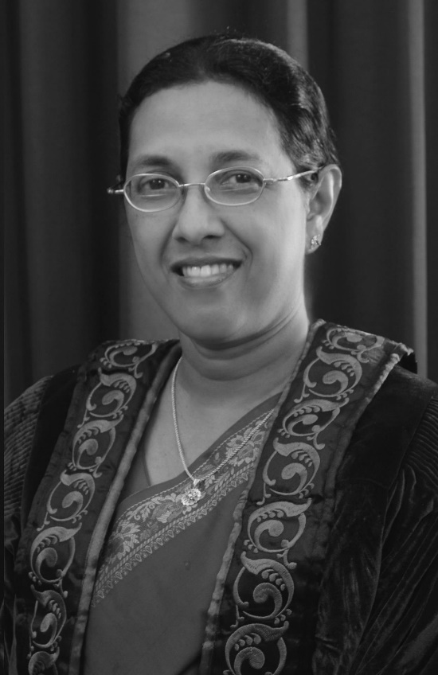
Shironica P. Karunanayaka is Professor in Educational Technology and the current Dean of the Faculty of Education at the Open University of Sri Lanka (OUSL) where she has been housed since 1993. Prof. Karunanayaka holds a first class in the Bachelor’s degree in Science from the OUSL, the Post Graduate Diploma in Education from the University of Colombo, and the Degree of Doctor of Education from the University of Wollongong, Australia, specializing in Information Technology in Education and Training. Being an active researcher, Prof. Karunanayaka has many publications in both national and international fora. Her key research focus areas include ICT in education, instructional design for enhancing learning and teaching experiences, open educational resources, and open educational practices.

References
Brown, J. S., Collins, A., & Duguid, P. (1989). Situated cognition and the culture of learning. Educational Researcher, 18(1), 32–42.
Karunanayaka, S., & Naidu, S. (Eds.). (2014). Integrating OER in educational practice: Practitioner stories (ISBN 978-955-23-152-68). Nugegoda: The Open University of Sri Lanka. Retrieved from www.ou.ac.lk/home/images/OUSL/publications/intergratingOERinEducationalPractice.pdf
Karunanayaka, S., & Naidu, S. (2017). Impact of integrating OER in teacher education at the Open University of Sri Lanka. In C. Hodgkinson-Williams & P. B. Arinto (Eds.), Adoption and impact of OER in the global South (pp. 459–498). Cape Town & Ottawa: African Minds, International Development Research Centre & Research on Open Educational Resources. doi:https://doi.org/10.5281/zenodo.10005330
Karunanayaka, S., Naidu, S., Rajendra, J. C. N., & Ariadurai, S. A. (2018). Designing continuing professional development MOOCs to promote the adoption of OER and OEP. Open Praxis, 10(2), 179–190. doi:http://dx.doi.org/10.5944/openpraxis.10.2.826.
Kinskey, C., King, H., & Carrie, L. M. (2018). Open educational resources: An analysis of Minnesota state colleges and universities student preferences. Open Learning: The Journal of Open, Distance and e-Learning. doi:https://doi.org/10.1080/02680513.2018.1500887
Merrill, M. D. (2002). First principles of instruction. Educational Technology Research and Development, 50(3), 43–59.
Morrison, D. (2013, April 22). The ultimate student guide to xMOOCs and cMOOCs [Web log post]. Retrieved from http://bit.ly/ZDCQzW
Naidu, S. (2010). Using scenario-based learning to promote situated learning and develop professional knowledge. In E. P. Errington (Ed.), Preparing graduates for the professions using scenario-based learning (pp. 39–49). Brisbane, Australia: Post Pressed.
Naidu, S. (2013). Transforming MOOCs and MOORFAPs into MOOLOs. Distance Education, 34, 253–255. doi:10.1080/01587919.2013.842524
Naidu, S. (2017). Open educational practice: Caveat Emptor. In D. Singh & C. Stückelberger (Eds.), Ethics in higher education: Values-driven leaders for the future (pp. 287–305). Geneva: Globethics.net, ISBN 978-2-88931-164-4 (online version) ISBN 978-2-88931-165-1 (print version).
Naidu, S., & Karunanayaka, S. (2014). Engines of education: Integrating OER in learning and teaching. In S. Karunanayaka & S. Naidu (Eds.), Integrating OER in educational practice: Practitioner stories (pp. 3–22). The Open University of Sri Lanka. Retrieved from www.ou.ac.lk/home/images/OUSL/publications/intergratingOERinEducationalPractice.pdf
Rajendra, J. C. N., & Ariadurai, S. A. (2018). Designing continuing professional development MOOCs to promote the adoption of OER and OEP. Open Praxis, 10(2), 179–190. doi:http://dx.doi.org/10.5944/openpraxis.10.2.826
Reeves, T. C. (2006). Design research from a technology perspective. In J. van den Akker, K. Gravemeijer, S. McKenney, & N. Nieveen (Eds.), Educational design research (pp. 52–66). London: Routledge. Retrieved from www.fisme.science.uu.nl/publicaties/literatuur/EducationalDesignResearch.pdf#page=102
Reeves, T. C., & Hedberg, J. G. (2014). MOOCs: Let’s get REAL. Educational Technology, 54(1), 3–8.
Romiszowski, A. J. (2013). What’s really new about MOOCS? Educational Technology, 53(4), 48–51.
Senack, E. (2014). Fixing the broken textbook market: How students respond to high textbook costs and demand alternatives (Report). Washington, DC: PIRG Education Fund and the Student PRIGS. Retrieved from https://uspirg.org/reports/usp/fixing-broken-textbook-market
Siemens, G. (2008–2012). MOOCs [Series of blog posts]. Connectivism. Retrieved from www.connectivism.ca/?s=MOOC
UNESCO. (2002). Forum on the impact of open courseware for higher education in developing countries. Final report. Retrieved from www.unesco.org/iiep/eng/focus/opensrc/PDF/OERForumFinalReport.pdf

