Biofuels and Fiji’s roadmap to energy self-sufficiency

Anirudh Singh
School of Engineering and Physics
The University of the South Pacific, Laucala Bay, Suva, Fiji
Ph: +679 3232437 email: singh_ag@usp.ac.fj

Draft

Abstract
The Pacific Island Countries (PICs) face a number of energy challenges, arising mainly from the lack of indigenous fossil fuel sources and their remoteness. Biofuels provide one of the possible solutions. This paper considers the current status of the biofuels industry in Fiji and stresses that the main motivation for biofuels development in the Pacific must remain the substitution of expensive fossil fuel imports and not the reduction of carbon emissions. It identifies coconut oil and ethanol as the two most important biofuels that can be produced in Fiji today, and outlines some of the socio-economic factors that influence the production of these biofuels. The paper considers Fiji’s prospects of replacing its fossil fuel imports by biofuel, and concludes that in the case of transportation, Fiji is well-placed to replace all its diesel engine needs by the biofuel blend B5 and its petrol engine needs by the ethanol blend E10. Indeed, with a little more attention to feedstock production, Fiji could become a net exporter of these commodities in the not-too-distant-future.

1. Energy challenges of Fiji and the Pacific Island Countries
1.1 Introduction
Biofuels provide one of the solutions to the number of energy challenges faced by the Pacific Island Countries (PICs). The absence of indigenous fossil fuel resources in these countries leaves them with no option but to import their fuel requirements at considerable costs. Their remoteness from the normal fuel supply lines leads to fuel supply chain issues, and incurs additional costs. As Figure 1 reveals for the case of Fiji, fuel bills invariably form a major component of the total import bills for these fragile economies.

(Figure 1: Fuel import for Fiji in comparison to its total import bill).

The dependence of these countries on imported fuel for essential needs such as power generation makes these nations prone to severe oil price shocks, as the December 2008 global oil price spike demonstrated in the cases of the Kingdom of Tonga and the Republic of Marshall Islands (RMI). In the case of Tonga, the nation was obliged to take serious stock of its energy situation and embark upon a concerted mission to reduce its imported fuel dependency[1]. Marshall Islands on its part had to declare a state of economic emergency, during which the nation was reduced to drawing funds from other allocations to pay for their fuel import bills. [2].

1.2 Finding solutions
In their quest to overcome these challenges, the PICs have considered both collective and individual solutions. They involve, amongst other things, the replacement of fossil fuels by renewable energy.

There are many ways to tackling problems of this scale and nature. An obvious example is to use a systems analytical approach commonly employed, for instance, in information systems [3]. Whatever the chosen methodology, the essential elements remain the same. They are to:
- Investigate the nature of the problem
- Propose a solution
- Identify the components of the solution and show how they are linked
- Design the solution
- Implement the solution
- Test the solution and review it periodically to maintain it

In the present context, this would reduce to the following specific steps:
- identify the energy resources
- determine the other requirements necessary for the achievement of the solution
- develop a plan for implementing the solution
- implement the solution

Two essential criteria any energy strategic plan for the PICs must satisfy are that it is relevant to the PICs, and is sustainable over time and is resilient to changes in circumstances.

The PICs have evolved their own method for dealing with their energy problems. It incorporates many of the features of the above methodology, as well as introducing some novel ones. They have noted that part of the solution is the replacement of imported energy with indigenous energy, as well as making better use of imported energy through energy efficiency and conservation measures. But they have also realized that the success of any plan would rely on integrated support from several governmental and institutional sectors, as well as taking into account issues of national sovereignty and cultural identity.

The most obvious alternative energy solution that presented itself was renewable energy (RE). But several issues had to be addressed before RE became a viable solution. The availability of the indigenous RE resources was restricted by the region’s geography and geology, and varied significantly from country to country. Many PICs are low-lying coral atolls, with no possibility of hydro energy and only limited possibility of biomass/biofuel resources. The problem was exacerbated by the region’s lack of human capacity and institutional mechanisms to develop its RE resources.

These issues have been subjected to detailed scrutiny over the past decade by regional organizations such as the Pacific Island Forum and agencies including SOPAC, SPREP, and SPC with assistance from developed nations and international aid agencies. After a false start, the PICs are now in the process of developing strategies at both the regional and national levels that are holistic and innovative, and promise to deliver realistic solutions to the region’s energy problems.

While biofuels are normally considered in the context of global greenhouse gas abatement, they also play an essential role in the delivery of viable solutions to the Pacific region’s energy challenges. Notable examples of biofuel developments that are currently taking place at the regional level are the national efforts in Samoa to establish a biogasification power plant [4], and the Fiji government’s concerted programme of activities to establish the foundations of a certified biofuels industry in the country [5].

This paper elaborates on such developments by assessing the current status and future prospects of the biofuel industry in Fiji. In the sections that follow, it first considers the overall energy requirements of the PICs, and assesses the role biofuels play in the sustainable development of these countries. It next considers the current status of the biofuel industry in Fiji, and the steps that can be taken, or are being taken, to develop this industry. It stresses that the primary, if not the sole aim of Fiji’s biofuel initiative should be the replacement of foreign oil import by indigenously-produced energy sources, and that any consideration of assisting in the global campaign to reduce carbon emissions should be a secondary aim at best.

The paper next considers Fiji’s transportation sector, which is totally dependent on imported fossil fuels, and assesses the possibility of Fiji producing its own land transport fuel for diesel (or Compression Ignition) and petrol (or Spark Ignition) engines. It concludes that Fiji is currently producing enough feedstock to meet all its own ethanol blend (E10) requirements for petrol engines. Furthermore, with a little attention to feedstock production, it could also meet its biodiesel blend (B5) requirements for diesel engines in the not too distant future.

2. Energy requirements for Fiji and the PICs
2.1 Energy benchmark for Fiji and the PICs
Energy is essential for the development and sustenance of the economic infrastructure of any country. Modern energy such as electricity assures access to a range of services and facilities that improve the quality of lives. As the Pacific Island Countries (PICs) are developing nations, it is natural to consider which energy benchmarks they should use to assess their progress towards their development goals. As such benchmarks are provided by developed nations,, it is instructive to begin by considering the energy use patterns in Australia, the most developed neighbor of the PICs.

Australia’s use of energy is divided into power (30.5%), transportation (23.2%), manufacturing (22.5%), mining (7.5%), residential (7.4%), commercial (4.6%), and agriculture (1.6%) [6]. In comparison the final energy consumption in Fiji consists of power generation, industrial and commercial (36%), transportation (23.2%), residential (14%), and agriculture and mining (8%) [7].

Because of their relative economic status, the energy needs for the PICs are expected to be somewhat different from those of developed nations. In particular, we expect manufacturing and mining to play a minor role in energy consumption in the PICs. This is generally so for the coral atoll states. Exceptions arise for the volcanic islands, which include Papua New Guinea, Solomon Islands and Vanuatu in the West, and Fiji and Samoa to the East (see Figure 2). In Papua New Guinea and Fiji, for instance, manufacturing and mining activities consume a significant portion of the energy supply.

Figure 2 : Map of the Pacific showing the Pacific Island countries and their developed neighbours.

In the case of Australia, we note that power generation and transportation consume the largest portion of the country’s energy production As these sectors are important pre-requisites to a growing economy and the improvement of the quality of life, transportation and power generation must be considered as essential components of the energy needs of developing countries.

2.2 Power generation and use
Power generation is one of the sectors in the PICs which relies most heavily on imported fuels. The situation is worst for the coral island states such as Kiribati, Nauru, Marshall Islands, and also Tonga, which rely totally on imported fuels for their power generation. In the case of Fiji, the power generation mix in 2010 consisted of 49% fossil fuel and 49% hydro, the rest being provided by wind and biomass [8].
Electricity provides better lighting, cooking, cooling and home entertainment, all of which improves comfort and enjoyment of life in the PICs. Indeed the availability of electricity is a good indicator of the state of development of a country. Power generation is thus given a high priority in the development agendas of all PICs. Table 1 shows the sectoral distribution of electricity use in Fiji.

Table 1: Electricity consumption by sector in Fiji 2010

The table reveals that power demand in Fiji is mainly for the commercial, domestic and industrial sectors (in that order).

2.3 Transportation
While imported fossil fuels are important for power generation in Fiji and the PICs, they are indispensible for their transportation sector. This sector may be conveniently divided into land transportation, shipping and the tourism-related aviation industry. In 2010 there were 167,085 road vehicles in Fiji, including 89,422 private cars, 5440 taxis, 6,991 rental cars, 43,722 goods vehicles and 2279 buses [9]. As tourism is a vital foreign income earner for most PICs, a considerable portion of the total energy supply is dedicated to the aviation industry to service tourism. As shown in Figure 3, in 2010 for instance, 27% of the total fuel imports bill for Fiji was due to aviation turbine fuel for the airline industry.

Figure 3: Cost of Fiji’s fuel imports by sector – (2005 – 2010)

We have noted above that while transportation and power generation are the two sectors that are most relevant to the development of Fiji and the other PICs, both these rely heavily on imported fossil fuels. They thus produce a heavy toll on the import bills of these states. Indigenously-produced biofuels can help alleviate this situation. This emphasizes the importance one must attest to the development (resources permitting) of the biofuel industry in the Pacific.

3 . Current status of the biofuel industry in Fiji
3.1 The importance of biofuels
Fiji’s fossil fuel imports are used for power generation, transportation and to a lower extent for cooking and heating in the domestic and industrial sectors. They can be replaced by hydro, biomass, wind and solar energy for most of these energy requirements. In the case of transportation, however, biofuels will remain the only viable renewable energy alternative for a long time. This is due to the current lack of readiness of other technologies such as fuel cells and electric cars to displace fossil fuels within the transportation industry in Fiji and globally.

Biofuels therefore play a crucial role in the transportation sector of Fiji (and the other PICs). They can satisfy this role through the provision of biodiesel and its blends with petroleum diesel for diesel (i.e. compression ignition or CI) engine vehicles, and ethanol and its blends for petrol (i.e. Spark Ignition or SI) engine vehicles. Biofuels can also provide an important component of the energy mix for power generation in Fiji by substituting for the fossil fuel component.

3.2 Potential biofuels for Fiji
Among the possible indigenous biofuels or biofuel feedstocks that are currently produced, or can be readily produced in Fiji are coconut oil (CNO) and its derivatives, and ethanol. Of these, the most readily and widely available is CNO. It can be used directly in diesel (CI) engines or as blends with petroleum diesel after steps have been taken against the possible deleterious effects of such vegetable oil blends on the engine. Other vegetable oil fuel feedstocks for diesel engines being considered in Fiji are jatropha, pongamia and castor oil [101]. These vegetable oils can also provide the feedstock for the production of biodiesel.

Alternative fuel possibilities for petrol (SI) engines are provided by ethanol and its blends, mostly notably E10.

3.3 Estimating Fiji’s coconut resources
Estimates of coconut production potential in Fiji have varied widely, with a figure of some 50,000 hectares (ha) of plantation being the most common. Up till two years ago, it was also commonly held that many of the coconut trees on the existing plantations were senile (i.e. no longer produced coconuts). These data and inferences were probably based on Fiji’s agricultural census carried out in 1991.

Updated data is now available from the most recent agricultural census, which was carried out in 2009 by the Ministry of Primary Industries. The results are contained in the Report on the Fiji National Agricultural Census 2009 [10]. They show a total plantation area of 15,009 ha, of which 14,270 ha are classified as bearing. When the 2748 ha due to scattered trees is added, this figure increases to 17,757 ha.

A recent guestimate by the Fiji Department of Energy suggests that on the assumption that each hectare of plantation produces 3 to 10 tonnes of copra (and adopting the conservative estimate) the existing coconut plantations should yield close to 45,000 tonnes of copra annually. Extending this exercise further, on the basis that one tonne copra can be used to produce 600 litres of oil, one obtains a figure of 27 million litres of coconut oil as the total potential yield per annum [11]. When these figures are compared with the 2010 estimate of 4 million litres of oil exported by Fiji [12], the low productivity of one of Fiji’s major primary agricultural industries is all too obvious.

3.4 The dynamics of copra production
As noted above, the actual production of coconut oil (CNO) from existing coconut plantations in Fiji has been far below expectations. Indeed, it has been declining steadily over the decades as Figure 4 reveals.

Figure 4 Trend in Fiji’s coconut oil production – selected years

The possible reasons are numerous and complex, including the effect of natural disasters such as cyclones and droughts, and urban migration. Social factors as well as physical and economic ones have also been quoted [13]. But among the reasons one must also include the labour intensive nature of copra production. Copra cutting is a laborious task. Thus, when the price of copra falls on the world market, there is little incentive for village communities to produce copra for export.

The use of CNO as alternative fuel to diesel is determined by the relative price of the two fuels. The price of petroleum diesel increases with distance from the main island, due to the additional costs of transportation to the outer island. Thus, where the diesel prices are high enough, it becomes cheaper to use CNO as alternative fuel, [14]. The price fluctuations of copra on the world market, however, frequently makes it more profitable for producers to sell their copra for export rather than CNO production, forcing up the price of the latter commodity.

3.5 Fiji’s new outer island biofuels initiative
But recently the Fiji government has adopted a strategy that take these factors into account, and which shows great promise for the establishment of a viable CNO-derived biofuel industry that can provide for much of the basic electricity generation needs of Fiji’s outer islands [5].

The new strategy is based on the observation that oil production prices can be significantly reduced if small oil mills are constructed on the outer islands (see Figure 5), close to the copra supply, thus eliminating the need to ship the copra to the main islands of Viti Levu and Vanua Levu where the large mills are based. It utilizes the existing social structures on the islands to set up community-based cooperative enterprises that own the new mills. These mills purchase the copra from the community, produce CNO and other byproducts, and sell the CNO back to the community at a price that is competitive with that of imported diesel. Each mill has a capacity of extracting 170,000 liters of oil per annum.

Figure 5 Map of Fiji, showing the two main islands of Viti Levu and Vanua Levu, surrounded by the smaller outer islands.

This programme of rural electrification via local production of CNO began in 2010 . Mills and supporting management structures have already been established on the island of Rotuma (500 km North of Fiji), and the outer islands of Koro and Cicia. Feasibility studies are now being carried out on the outer islands of Moala, Matuku, Lakeba, Gau and Kadavu. There are plans for a total of twenty such mills to be established on the outer islands by 2013 [5].

3.6 CNO blends and biodiesel
Certain challenges must be overcome before the use of vegetable oils such as CNO and their blends as alternative fuels for diesel engine vehicles become viable. As the present cadre of diesel engines were not constructed for these fuels, they are generally not suitable for the engines, leading to inefficiencies and potential engine damage. (see table in Box 1 for a comparison of biodiesel properties to those of petroleum diesel).

In addition to the problem of the engine suitability of biofuel blends, there is a need for control over engine emissions to ensure environmental emissions are kept at acceptable levels. All these problems are overcome if the vegetable oil is first converted chemically to biodiesel. This new fuel has fuel properties which are in instances superior to that of petroleum diesel, and emissions which are generally quite acceptable. They can be used in the pure form (dubbed B100) or as a blend with petroleum diesel.

The Fijian government’s biofuel program for outer islands is currently based on the use of blends consisting of 20% CNO/80% petroleum diesel. The government has now decided to opt for the use of 100% CNO with modified diesel generators. This will simplify the process of converting to indigenously-available renewable energy. The modification will be via the addition of a simple duel fuel kit to the engine assembly. This is essentially a simple heat exchanger that reduces the viscosity of the fuel by heating it to a temperature of 90 Celsius before injection into the chamber [5].

The emergence of a variety of suppliers on the market, and the need to safeguard the consumer has prompted the government to introduce biofuel standards tailored for the local conditions.

3.7 Other feedstock for diesel (CI) engine fuels
Apart from coconut, other feedstock for the production of diesel engine fuels that are actively being pursued in Fiji are pongamia, jatropha and castor. The most notable of these ventures is that of Biofuels International [101], a company that is currently establishing plantations of these feedstocks on the island of Vanua Levu (the smaller of the two main islands of Fiji). Its initial projections are 4.8 million litres of pongamia oil per annum. Reports of smaller farms of jatropha on the larger main island of Viti Levu emerge on the media from time to time. These however cannot be substantiated.

3.8 Ethanol for petrol (SI) engine vehicles
A lot of interest has been shown over the past four years in the production of ethanol from both sugarcane-related feedstock and cassava as a fuel additive for petrol (SI) engine cars.

The sugarcane industry, which has the potential of producing either sugarcane juice or molasses as feedstocks for ethanol production, has been the mainstay of the Fijian economy over the past century. However, this industry has recently been in a state of decline.

Fiji’s sugar industry had its beginnings in the early stages of the country’s colonial era (1879-1970) during which farming of the largely native-owned land began under the tenureship of the Australian-owned Colonial Sugar Refining Company (CSR). Land was leased in small 2-4 ha leaseholds by descendents of the original indentured Indian labourers as well as a smaller number of indigenous farmers under an all-encompassing scheme known as the Master Award.

The sugar exports enjoyed special preferential (above world market) prices under the EU-ACP Sugar Protocol with the European Union [15], [102]. The industry has been in a state of decline since the year 2000 when the cane-farming leases began expiring. The industry suffered a second setback in 2009 when the Sugar Protocol was abolished. As a result of these and other social factors, cane farmers have continued to drift away progressively from cane farming, their numbers dropping from 22,179 in 2000 to 16,827 in 2010. The result has been a sharp drop in sugarcane production from 3,786,000 tonnes in 2000 to a mere 1,778,000 tonnes in 2010 (see Figure 6). During the past four years, interest has arisen in the possibility of using this agricultural product as feedstock for ethanol production. In 2008, the Sojitz Corporation of Japan showed interest in the possibility of producing ethanol from sugarcane juice or molasses [16], [103].

The possibility of extracting ethanol from cassava has also been considered, after the Chinese example, recently [17]. The proposed venture would have required very large tonnages of cassava. With doubts as to whether this could be achieved, especially as no feasibility studies had been carried out, interest in this prospect has waned.

Despite this pessimistic outlook for Fiji’s sugar industry however, there is convincing evidence that enough feedstock can be produced currently by Fiji for the production of ethanol on a commercial scale from both sugarcane and cassava-based feedstocks (see section 5).

4. Developing Fiji’s biofuel industry
4.1 Introduction
Before considering how Fiji’s biofuel industry can be developed, it is instructive to consider once again the motivation for such development. The reasons commonly assumed for the development of biofuels as substitutes for fossil fuels is to contribute to reductions in global carbon emissions. The PICs, however, are amongst the lowest carbon emitters per capita in the world. Apart from Nauru and New Caledonia, the carbon footprints of all PICs fall well below the global average of 4 tonnes per capita [104, 105]. With a footprint of 1.7 tonnes, Fiji is ranked at 131, while Kiribati’s 0.3 tonnes per capita rates this Pacific nation as the 183rd emitter of the world.

Considering the insignificantly small population of the PICs (of some 10 million people) on the global scale, it is abundantly clear that the effect on global carbon emissions of replacing the fossil fuel usage of these countries with biofuels will be miniscule. The primary objective of the biofuel programmes of Fiji and the other PICs must therefore remain the improvement of their economic status through the replacement of expensive imported fuels. It is also irrelevant to the argument that first generation biofuels such as CNO and ethanol, which have dubious merits as greenhouse gas abatement agents, are used for this purpose.

So what is the recipe for the effective development of Fiji’s biofuel industry? The answer lies in the availability of resources, and the capacity of the country to develop these resources. In particular, it depends on the human capacity, including the scientific and technological know-how, as well as the policy and regulatory frameworks and the institutional capacity that facilitate such developments. To begin the process however, one needs information on the resources.

4.2 Data on biofuel resources
The resources needed to develop the biofuel industry in Fiji and the region include the current feedstock plantations as well as suitable land area for the further development of such plantations. The major issue for planners and implementers with resources has been the availability of data. While some data exists on the available feedstock for the production of biodiesel and ethanol, this has largely been sparse and unreliable.

Tables 2 and 3 provide estimates of coconut oil (CNO) and cassava production in the PICs [106].

Table 2: Potential for CNO production in the PICs

Table 3: Cassava production in the PICs

Data on Fiji’s sugar and molasses production has been more readily available. Figure 6 presents such information for the previous ten-year period.

Figure 6: Fiji’s Sugar and molasses production 2000-2010

4.3 Land resources in Fiji
Fiji’s total land area of some 1.8 million hectares (ha) may be broadly divided into flat land (16%), undulating or hilly land (17%) and steep, mountainous land (67%). Not all of this land resource is suitable for agriculture however. Of the total, only 19% is suitable for agriculture with or without minor improvements. The rest requires major improvement, or is unsuitable [107].

The actual agricultural land use data by the major crops in 2009 is compared to that of 1999 in Table 4. Note this excludes timber plantations, of which pine and mahogany formed the largest components at the end of 2010. (Fiji’s pine plantation in 2005 covered 48,770 ha of land [18] while the mahogany forests occupied 40,000 ha [108]) . The general decline in production for sugar, coconut and rice over the ten years between 2009 and 1999 is obvious. In 2009, the total land area farmed in Fiji was 251,858 ha, of which 23,483 ha (i.e. nearly 10%) lay fallow for more than a year [10].

Table 4: Agricultural land use in Fiji (1999, 2009)

4.4 Human capacity
As noted earlier, one of the major problems Fiji and the region has to solve is the lack of human capacity and institutional mechanisms to develop its RE resources.

Until recently, this was a problem shared by the biofuels sector as well in Fiji. But over the last five years, the following developments have taken place:

- The Fiji Department of Energy has established a biofuels unit with staff with experience in biofuels research
- The University of the South Pacific (USP) has begun to produce graduates with scientific training in biofuels
- Both the Fiji National University (FNU) and USP now offer programmes of study in Renewable Energy, which include biofuels as an important component
- The Energy Department’s biofuel unit has developed a biofuels standards for Fiji, and legislation is now in place to enforce these standards
- USP is now in a position to carry out some of the simpler biofuel tests which can be used in the testing and certification of new biofuels offered on the market.

These developments, though not sufficient in themselves, have nevertheless put Fiji well on the path of acquiring the scientific and technical know-how for the development of a home-grown biofuels industry.

4.5 Policy frameworks
Policy development is the first step towards finding solutions to the energy challenges of the PICs in general, and to the development of its biofuels industry in particular. The region has begun well in this direction. What is required is a regional framework to cater for the common needs, and national energy policies to address the individual energy needs of each nation. These regional and national policy structures have been under active development in the Pacific from as early as 2004 under the guardianship of several regional institutions and agencies [19].

The Pacific Islands Energy Policy (PIEP) [20] was the first of the regional energy policies to be formulated. Enacted in 2004, it was to act as a guideline document for national energy policy developments and initiatives in the Pacific Island Countries and Territories (PICTs). However it was largely ineffectual in achieving its objectives, and in 2009, it was decided to replace PIEP by a new regional energy framework that assured greater energy security in the Pacific.

At the 40th Pacific Island Forum meeting in Cairns, Australia (April 2009), the Pacific leaders gave the directive that eventually led to the formation of the Framework for Action on Energy Security in the Pacific (FAESP) in 2010 [21]. This new framework utilizes a whole-of-sector approach to energy security, and recognizes the need for continued dependency on fossil fuel in the near future. Together with its associated Implementation Plan for Energy Security in the Pacific (IPESP 2011-2015) [22], this new regional policy introduces a more pragmatic and holistic approach to regional energy planning that learns from past mistakes and in fact establishes a new paradigm in regional policy-making.

The national energy policies (NEPs) generally have similar structures. They provide broad policy frameworks for the country and support large (national) grids that supply urban areas, and Rural Electrification Policies/programmes (REPs) for rural regions that provide for small-grid or standalone (small home system) electrification schemes.

4.6 Enterpreneurial capacity
The above factors provide the essential environmental building blocks for the establishment of a biofuels industry. However, for the industry to operate as an enterprise, it needs entrepreneurs to drive it.

It is reassuring therefore to observe that several private companies have shown intense interest in the new industry, and have begun producing biofuels or feedstock for diesel engine vehicles [101]. Initially, production by these private concerns was restricted to CNO-diesel blends (which were erroneously dubbed as “biodiesel”). At least one private company has now begun producing trans-esterified biodiesel (CME) from local CNO feedstock.

5. Future perspectives
5.1 Introduction
As noted earlier, the primary aim of the Pacific’s biofuel program is the substitution of imported fossil fuel. As reduction in global carbon emissions is only a secondary goal, the usual arguments about the purported inefficacy of first generation biofuels such as CNO or ethanol in reducing carbon emissions [23, 24] do not apply. The only consideration of relevance is the replacement of imported fuels by home-grown ones, and both CNO and ethanol are perfectly suitable for this purpose.

The interesting question that must be addressed is how effective will a program of import substitution by biofuels be for Fiji and the PICs. As the analyses that follow will show, the prospects, in the case of Fiji, of achieving such a goal are more than good.

5.2 Establishing a baseline for Fiji’s fuel consumption
What are the chances that Fiji can succeed in its endeavor to replace the country’s fossil fuel imports by biofuels?

While an initial assessment of this prospect may be a pessimistic one, the results of a back-of-the-envelope analysis are however, somewhat surprising, and highly instructive. To answer the question, one must start with an estimate of the current fuel usage of the country. The actual figures for this are unavailable at the moment because of the reluctance of the oil companies to release them. However, they were available up till 2004, and these earlier values may be used as a reasonable approximation for current usage. Table 5 provides a summary of the retained fuel imports in Fiji in 2004.

Table 5: Retained volumes of imported fuels in Fiji, 2004

5.3 Fiji’s land transportation sector – biofuels for diesel and petrol engines
We have noted above that biofuels are needed to rid Fiji’s dependence on imported fossil fuels mainly in the transportation and the power generation sectors. As the intention of the Fiji Electricity Authority, the country’s national electricity utility, is to employ hydropower, biomass and wind energy to reduce its imported fuel dependency [25], the impact of any biofuels initiative in Fiji will be mainly on the transportation sector.

For the purpose of this assessment, therefore, let us confine ourselves to Fiji’s land transportation sector, and consider diesel engine fuels first. One must first acknowledge that the future prospects of the use of vegetable oils in their pure form and as blends are questionable because of their possible harmful effects on vehicle engines. It is also doubtful whether they will be able to satisfy vehicle manufacturer’s strict fuel quality requirements, leading to problems with car insurance policies, and making these fuel blends very unpopular at best.

The more probable route to biofuel utilization in land transportation would be via the conversion of the oils to biodiesels through trans-esterification, and the production of blends of this superior quality (and more acceptable) fuel.

In the case of ethanol use for petrol (SI) engines, the ethanol may be blended directly with the petrol (i.e. gasoline) provided appropriate attention is given to the water content of the ethanol (which is normally produced as 95% ethanol).

There are two cases to consider:
- Case1: total replacement of the fossil fuel imports with biofuel
- Case 2: production of B5 biodiesel blend for diesel (CI) engines and E10 blends for petrol (SI) engines.

5.4 Case 1: Total replacement of fossil fuels by biofuels
5.4.1 Replacing Diesel (CI) engine fuel by pure biodiesel:
The 5 million litres of CNO produced in 2010 will yield 4.2 million litres of biodiesel . This estimate is based on the assumption that one litre of oil will produce 0.8 litre of biodiesel [26]. This amounts to only 4.2 % of the total petroleum diesel consumption (of about 98 million litres) per year in Fiji.

We see that to convert all cars currently using automotive diesel oil (ADO) to pure biodiesel (B100) would require a 25-fold increase in the country’s CNO production. Even when the inefficiencies of CNO production noted in section 3.4 are accounted for, a mere six-fold increase in biodiesel will result. The use of pure biodiesel for Fiji’s land transportation requirements is thus not a viable option for the immediate or intermediate future.

5.4.2 Replacing petrol (SI) engine fuel with pure ethanol:
Some 30.5 million litres of ethanol can be produced from the 113,000 tonnes of molasses produced by Fiji annually [27]. The factor of 270 litres of ethanol to one tonne of molasses used for this conversion is due to Deverall [28]. This is consistent with the value from the alternative source [109].

This is 47% of the assumed total volume (of 65 million litres) of petrol consumed by petrol vehicles in any year. However, it must be noted that current generation car engines available in Fiji cannot use pure ethanol (E100) in their unmodified form. Presently, E10 is the only viable candidate for an alternative ethanol blend for unmodified petrol engines. Therefore, it is more meaningful to assess the potential use of this latter blend for petrol engines. This analysis is carried out below.

5.5 Case 2 – Production of blends for diesel (CI) and petrol (SI) engines
5.5.1 Production of biodiel blend B5:
If all the 4.2 million litres of biodiesel that could be realized from the present production of 5 million litres of CNO were to be utilized in the production of the biodiesel blend B5, then some 83 million litres of B5 would be produced per annum, which will provide 85% of the present CI engine fuel needs (of 98 million litres) in Fiji. Thus, only a small improvement in the efficiency of CNO production in Fiji would be required to convert all diesel-operated land transport vehicles in Fiji to the more environmentally-friendly B5 fuel blend.

5.5.2 Production of E10 from ethanol
The two sources of ethanol feedstock in Fiji (molasses and cassava) are evaluated as follows:

A total of 305 million litres of E10 can be produced from the 113,000 tonnes molasses produced by Fiji’s sugar industry in 2010. This is 469% of the total petrol vehicle fuel requirements for the country. Fiji will thus be in a position to produce quantities of E10 that are surplus to its requirements.

The nation can also produce 4.8 million litres of ethanol from its present output of 51,690 tonnes of cassava [29]. The factor of 94 litres of ethanol to one tonne of cassava, which was determined experimentally [30], was used in this conversion. This volume of ethanol can produce 48 million litres of E10, which is 75% of the total petrol engine requirements for the country. The relatively lower volume of ethanol per tonne of substrate for cassava as compared to molasses is to be noted. Coupled with the observation that molasses is a byproduct whereas cassava has to be planted and nurtured especially for the purpose of ethanol production, the merit of cultivating cassava for ethanol production must be carefully scrutinized.

5.6 Fiji’s current biofuel potentials – the bigger picture
The following lessons are immediately obvious from the above exercise:
- If a little attention is paid to the productivity of Fiji’s plantations, coconuts alone could produce enough biodiesel blend B5 for the entire land transportation needs of the country

- There is sufficient molasses in the country to provide for conversion of all of Fiji’s petrol engine fuel to E10, and have remaining surplus for either export directly or through the production of more E10.

- The ethanol yield from cassava, a primary agricultural product, is a lot lower than that from molasses, a byproduct of the sugar industry. There is therefore little merit in pursuing the idea of cassava ethanol as long as the molasses alternative exists.

The analysis presented above gives a clear indication that (all other things being equal), Fiji may already have enough capacity to meet its B5 and E10 requirements, and to become a net exporter of pure ethanol and the B5 and E10 fuels.

5.7 The future of biofuels in Fiji
What is the most likely future biofuels scenario for Fiji?

The possibilities abound, but it is still illuminating to use what we know now to build a future perspective of the biofuels industry in Fiji. Firstly, the private sector interest in the industry is encouraging. This lies not only in the production of feedstocks such as jatropha, pongamia and castor, but also in the formulation and manufacture of new biofuels and their blends for the end-user.

The government, on its part, has taken initiatives to provide institutional mechanisms by starting with the establishment of biofuels standards and testing facilities. It is also making concerted efforts for the establishment of a biofuel-based rural electrification scheme for the outer islands that will utilize locally-available resources and reduce diesel fuel imports. All this will provide a sound basis for a vigorous biofuel industry that makes optimal use of indigenous renewable energy resources

Fiji has every likelihood of establishing a credible biofuel industry, based on the biofuel feedstock currently being investigated. Indeed, it has the potential to become self-sufficient in its fuel blend needs for both petrol (SI) and diesel (CI) engine vehicles. Private sector interest in developing the industry infra-structure is obvious. There is a ready market in Fiji’s Pacific neighbours, as well as further abroad, for any surplus products the country may produce.

Indeed, the availability of feedstock, technological infrastructure, and the required systems of standards and certification in Fiji will mean that Fiji will have every possibility of becoming a net exporter of SI and CI engine fuels in the not-too-distant future.

There are issues to consider, not the least being land ownership and availability. In the past, this has always been a difficult issue to contend with. But with the recent evolution in attitudes amongst all stakeholders in the industry, and the current government’s concept of creating land banks [110] that anyone is free to lease, will assist towards the resolution of this issue.

The picture cannot be complete without reference to future energy demand. Such demand side analysis is complicated however by future changes in demography due to migration. This will include population movement from rural to urban areas, and inter-island migration within Fiji, such as migration from Vanua Levu to Viti Levu and from the outer islands to the mainland (Viti Levu and Vanua Levu). As the energy use patterns of rural areas are different from those of the urban areas, this population change will be reflected in changes in energy demands.

Fiji’s Household Income and Expenditure Surveys of 2002/3 and 2008/9 contain data that is indicative of the rural- urban migration in the period between these two years. Table 6 presents this data, together with the estimated total population of Fiji in these years.

Table 6: Comparison of Fiji’s rural and urban populations in 2002/3 and 2008/9

The urban drift seems to be clear. Because of the inherent complexities arising from other considerations however, one can only provide a speculative assessment of the changed energy user situation in Fiji in the future.

It is clear, however, that as far as the overall energy situation in Fiji is concerned, biofuels will play a significant role in the reduction of Fiji’s dependence on imported fossil fuels. The future is bright.

6. Executive summary
6.1 Energy challenges of Fiji and the Pacific Island Countries (PICs)
- The Pacific Island Countries (PICs) face several challenges in their bid to replace fossil fuel imports with renewable energy.
- The PICs, with the help of regional organizations, have been actively developing strategies at both the regional and national levels, to achieve their energy aims.

6.2 Energy requirements for Fiji and the PICs
- Power generation and transportation are the two most important energy needs of the PICs.
- Power demand in Fiji is mainly for the commercial, domestic and industrial sectors.

- The transportation sectors of the PICs, which may be divided into land, shipping and aviation, are totally dependent on imported fossil fuels.

6.3 Current status of the biofuel industry in Fiji
- Biofuels will remain the only viable alternative fuel option for the transportation sector of Fiji for a long time due to the lack of readiness of other fuel technologies for transportation.
- Coconut oil (CNO) and ethanol provide the two indigenous biofuel feedstocks for Fiji, with jatropha, pongamia and castor oil also being considered.
- The Fiji Department of Energy (FDoE) estimates that at least 27 million litres of CNO can be produced from Fiji’s standing coconut plantation of some 15,000 ha.
- Numerous factors contribute to the efficiency of production of CNO from copra, including natural disasters and social, physical and economic factors.
- Fiji’s new outer island biofuel production strategy is making remarkable headway in electrifying the outer islands using modified diesel generators operating on 100% CNO.
- The high viscosities, low volatilities and reactivities of the hydrocarbon chains of vegetable oils produce deleterious effects on vehicle engines, which can be eliminated with the use of biodiesel.
- The Sojitz Corporation Limited of Japan has been showing interest in the production of ethanol from Fijian molasses since 2008, while Chinese companies have been interested in producing ethanol from cassava.

6.4 Developing Fiji’s biofuel industry
- The primary aim of any biofuels development programme in the PICs is the substitution of imported fuels, and not greenhouse gas reduction.
- While good data has always existed on Fiji’s sugar and molasses production, reliable data on Fiji’s CNO production has only recently become available via the National Agricultural Census of 2009.
- Only 16% of Fiji’s 1.8 million hectares of land is suitable for farming, and in 2009, the total land area farmed was 251,858 ha, of which 23,483 ha had lain fallow for more than a year.
- Over the last five years, human capacity for Fiji’s biofuel industry has been strengthened through the establishment of a biofuels unit within the Department of Energy, and training programmes at the University of the South Pacific (USP) and the newly formed Fiji National University (FNU).
- The PICs have been developing the Framework for Action on Energy Security in the Pacific (FAESP) and its implementation plan to achieve their energy aims.
- There is considerable interest from the private sector in the biofuels industry.

6.5 Future perspectives
- Fiji can produce enough biodiesel blend B5 for CI engines for the entire land transportation needs of the country from coconuts alone.
- Fiji currently produces enough molasses to convert all of Fiji’s petrol engine fuel to E10, and have remaining surplus for either export directly or through the production of more E10.
- The much lower ethanol yields from cassava as compared to molasses makes it uneconomical to pursue the cassava ethanol proposition.
- Fiji has the capacity of becoming a net exporter of petrol (SI) and diesel (CI) engine fuels in the not-too-distant future.

7. References
[1] Tonga Energy Roadmap 2010-2020, Final Report June 2010. Available at [112]
[2] Hon Matlan Zachras, Minister for Resource and Development. Keynote Address. Presented at: Renewable Energy Capacity Building Workshop for the North Pacific. International Conference Centre, Majuro, Republic of Marshall Islands, 7-9 September 2011.
[3] see e.g. Yeates D, Wakefield T, Cadle J. Systems analysis and design. 2nd ed (2003). Financial Times/Prentice Hall, UK.
[4] See website [116] or email info@mnre.gov.ws
[5] Pranil Singh. Biofuel Development in Fiji. Presented at: National Workshop on Energy Planning and Policy. Southern Cross Hotel, Suva, Fiji. 19-21 October 2011
[6] Energy in Australia 2010. ABARE, GPO Box 1563, Caberra, ACT 2601. Available from http://abare.gov.au
[7] Energy Statistics Yearbook 2000-2004. Fiji Department of Energy, p9.
[8] FEA annual report 2010. Available at www.fea.com.fj/pages.cfm/about-fea/downloads
[9] Key Statistics, June 2011. P119. Fiji Bureau of Statisitics, Suva, Fiji.
[10] Report on the Fiji National Agricultural Census 2009, Department of Agriculture, Economic Planning and Statistics Division, Suva, Fiji.
[11] Pranil Singh, Head of Biofuel Unit, Fiji Department of Energy, private communications, November 2011.
[12] Key Statistics, June 2011. P83. Fiji Bureau of Statisitics, Suva, Fiji.(Convert to litres using a density for CNO of 0.92 kg/l.
[13] Blair CW. The Coconut Fireant, or ‘A Technology Assessment using Actor-Network Theory to analyse the potential for coconut oil bioenergy in te Fiji islands’. MSc thesis,2004. Imperial College of Science, Technology and Medicine, University of London, Department of Environment, Science and Technology.
[14] Krishna I, Bukarau L, Fairburn P, and Mario R, Potential for Liquid Biofuels in Fiji, SOPAC Miscellaneous Report 677, March 2009. P43, Table 8.
[15] Agritrade, Executive brief update. March 2010. Sugar: Trade issues for ACP countries. Available at [109].
[16] Naivaluwaqa T, FSC seals ethanol deal. The Fiji Times. 20 September 2008.
[17] Vunileba A, $40million to save clans.The Fiji Times. 29 February 2008.
[18] Fiji Pine Ltd Annual Report 2005. Fiji Pine/Tropik Wod, Vakabuli Road, Drasa, Lautoka, Fiji.
[19] Singh A. Renewable Energy in the Pacific Island Countries – Resources, Policies and Issues, Management of Environmental Quality. in press 2011.
[20] Pacific Island Energy Policy and Plan, October 2002.
[21] Towards an energy secure Pacific, A Framework for Action on Energy Security in the Pacific, Secretariat of the Pacific Community (SPC), 2011.
[22] Towards an energy secure Pacific, Implementation plan for energy security in the Pacific [IPESP 2010-2015]. Secretariat of the Pacific Community (SPC), 2011.
[23] Crutzen PJ, Mosier AR, Smith KA, Winiwarter W. N2O release from agro-giofuel production negates global warming reduction by replacing fossil fuels. Atmos. Chem. Phys. Discuss. 7, 11191-11205 (2007).[24] de Fraiture C, Giordarno M, Yongsong L. Biofuels and implications for agriculture water use: blue impacts of green energy. Water Policy. 10 (S1) 67-81 (2008).
[25] FEA Annual Report 2010. P10.
[26] Beer T, Grant T, Campbell PK. The greenhouse and quality emissions of biodiesel blends in Australia, Report KS54C/1/F2.27. August 2007. CSIRO, Aspendale, VIC3195, Australia
[27] Key Statistics. Fiji Bureau of Statistics. June 2011. P36
[28] Deverall E. the Fijian Sugarcane Industry – investing in sustainable technology (2005). Oxfam briefing paper 77, Oxfam International, Oxfam, UK.
[29] Key Statistics. Fiji Bureau of Statistics. June 2011. P33
[30] Bijay P. Ethanol production from selected cassava varieties in Fiji and testing of ethanol/petrol blends. MSc Research, 2011, The University of the South Pacific, Suva Fiji

Websites
[101] www.biofuelsonline.net/home
[102] agritrade.cta.int/en/layout/set/print/content/view/full/1570
[103] ww.fijiembassy.jp/news/11/20110329.html
[104] www.eoearth.org/article/Cargon_footprint
[105] en.wikipedia.org/wiki/List_of_countries_by_carbon_dioxide_emissions_per_capita
[106] www.sopac.org
[107] www.fao.org/ag/AGP/AGPC/doc/Counprof/fiji.htm
[108] www.fijimahogany.com/about-sfi,htm
[109] journeytoforeve.org/biofuel/library/ethanol
[110] www.lands.gov.fj

Table and figure references
[1001] Key Statistics. Fiji Bureau of Statistics. June 2011. P37.
[1002] Krishna I, Bukarau L, Fairburn P, and Mario R, Potential for Liquid Biofuels in Fiji, SOPAC Miscellaneous Report 677, March 2009. P13, Table 8.
[1003] Krishna I, Bukarau L, Fairburn P, and Mario R, Potential for Liquid Biofuels in Fiji, SOPAC Miscellaneous Report 677, March 2009. P15, Table 9.
[1004] Energy Statistics Yearbook 2000-2004. Fiji Department of Energy, P17
[1005] Key Statistics. Fiji Bureau of Statistics. June 2011. P3 and P134
[1006] Key Statistics. Fiji Bureau of Statistics. June 2011. P77
[1007] Key Statistics. Fiji Bureau of Statistics. June 2011. P78
[1008] Key Statistics. Fiji Bureau of Statistics. June 2011. P34
[1009] Key Statistics. Fiji Bureau of Statistics. June 2011. P36

Keyterms

- PIC Pacific Island Country. One of the independent and self-governing island countries of the Pacific region, including Cook Islands, The Federated States of Micronesia (FSM), Fiji, Kiribati, Nauru, Niue, Palau, Papua New Guinea, Marshall Islands, Samoa, Solomon Islands, Tonga, Tuvalu and Vanuatu. These are also members of the Pacific Island Forum (PIF).

- Pacific regional organizations
SOPAC The Applied Geoscience and Technology Division of the SPC. This scientific body was formerly called the Pacific Islands Applied Geoscience Commission (SOPAC was the acronym for its French name).

SPREP South Pacific Regional Environment Programme. Based in Apia, Samoa, this regional agency is charged with protecting and managing the environment and natural resources of its 21 Pacific Island member states.

SPC Secretariat of the Pacific Community. A regional organization that provides development assistance to 22 Pacific island countries and territories. Its six divisions includes SOPAC. Its Economic Development Division provides advice, technical assistance and regional cooperation on transport, energy and ICT.

- Biodiesel An alternative fuel for diesel (CI) engines that is made from vegetable oils and other fats and oils through the chemical process of trans-esterification (see box). Biodiesel has fuel properties that match or are better than those of ordinary (petroleum) diesel.

- Types of vehicle engines
Spark Ignition (or SI) engine. A vehicle engine that runs on petrol (i.e. gasoline). It requires spark plugs to ignite the fuel/air mixture during the engine cycle.

Compression Ignition (or CI) engine. A vehicle engine that runs on diesel fuel (also called petroleum diesel). The fuel/air mixture in this engine ignites by itself when the compression is high enough (i.e. it auto-ignites, without the need for a spark from a spark plug).

- CNO Acronym for coconut oil. This vegetable oil is derived from coconuts, obtained from the coconut palm. The oil is usually extracted from copra, which is the dried meat obtained from a mature coconut.

- Fuel blends for vehicle engines
E10 This is a mixture of 10% ethanol and 90% petrol (i.e. gasoline) that is now used as an alternative fuel for petrol (i.e. Spark Ignition) vehicle engines.

B5 A blend of 5% biodiesel and 95% petroleum diesel for CI engines. It has excellent fuel properties and emission properties that are better than that of petroleum diesel.

- Pongamia, Jatropha and Castor plants The seeds of all these three plants produce non-edible oils that can be processed to produce biodiesel. All these plants can be grown under tropical conditions.

- Sugarcane This is a reed-like plant whose stem contains a sugar-rich juice. It is commonly planted for sugar production in the tropics and by countries such as Brazil for sugar production. Molasses, the by-product of the sugar production process, is rich in sugar and can be used for ethanol production.

- Cassava This is a common root-crop grown in tropical countries. The tubers that grow under-ground are rich in starch and can be used as feedstock for ethanol production.

Commentary Box

Biodiesel and ethanol blends as transportation fuels

Vegetable oils such as coconut oil (CNO) generally suffer from high viscosities, low volatilities and reactivity of the unsaturated hydrocarbon chains, and cause deleterious effects on diesel engines such as poor injection and atomization, carbon deposits on the injector nozzles and pistons, and sticky piston rings. These effects can be reduced significantly by the use of new biofuels, known as biodiesels, derived chemically from the oils.

The process, known as trans-esterification, involves the reaction of the oil, which is an ester containing three hydrocarbon chains (denoted as R below), with an alcohol such as methanol or ethanol in the presence of a catalyst. The products of the reaction are biodiesel, which are esters containing one hydrocarbon chain, and glycerol. When the alcohol is methanol, the overall reaction is represented by the chemical equation

C₃H₅(OOCR)₃ + 3 CH₃OH -> 3RCOOCH₃ + C₃H₅(OH)₃

Vegetable oil methanol biodiesel glycerol

As the new ester (the biodiesel) formed contains only one hydrocarbon chain as compared to the three hydrocarbon chains of the original oil, it is lighter and less viscous, and has other properties that make it a better fuel for diesel engines than the vegetable oil. Indeed, biodiesels have fuel properties that are generally superior to that of petroleum diesel. The Table below lists the important fuel properties for selected diesel (CI) engine fuels and includes petroleum diesel for comparison.

Properties of diesel (CI) engine fuels. (Source: various)

 | Energy value (MJ kg⁻¹) | Cetane number | Kinematic viscosity (cSt) | Solidification point  (ºC) | Iodine value (cg I g⁻¹ oil) | Saponification value (mg KOH g⁻¹ oil)
Desired value | high | high | low | low | low | high
Petroleum diesel | 45.5 | 47 | 4.3 | - 7 | - | -
Coconut oil (CNO) | 38.7 | 70 | 32 | 24 | 10 | 252
Soybean | 39.6 | 38.1 | 33.1 | - | 69.8 | 220.8
Rapeseed | 39.7 | 37.5 | 37.3 | - | 108.1 | 197.1
Biodiesel (CME) | 33-38 | 42 | 4.5 | -11 | 60 | -

Biodiesels also generally produce lower fuel emissions. Petroleum diesel produces carbon dioxide (CO₂), carbon monoxide (CO), nitrous oxides (NO_{x}), sulphur dioxide (SO₂) and several hydrocarbons in the engine exhaust. Emissions from biodiesel are generally lower, except for NO_{x} which shows a slight increase of 2-4% over petroleum diesel. Biodiesel also has superior lubricating properties, reducing engine wear. The Table includes the properties of the biodiesel known as coconut methyl ester (CME), produced by the reaction of coconut oil with methanol (i.e. methyl alcohol). Biodiesels can be used in the pure form (denoted B100) or as blends with petroleum diesel (for example B5).

Tables

Table 1 : Electricity consumption by sector in Fiji – 2010 (Source: [1001])
Sector | Quantity (kWh) | % of total (%) | Value ($FJ)
Industry | 210,482,315 | 25 | 49,667,792
Commerce | 372,551,529 | 45 | 114,809,634
Domestic | 252,134,739 | 30 | 61,052,604
Other | N/A | N/A | 1,408,374
Total | 835,168,583 | 100 | 226,938,404

Table 2 Coconut oil production potential in the PICs (Source: [1002])

PIC | Plantation area (hectares) | Coconut production (tonnes) | Coconut oil production (tonnes)
Fiji | 50,000 | 140,000 | 9,500
Papua New Guinea | 203,000 | 677,000 | 57,000
Samoa | 21,700 | 146,000 | 4,550
Tonga | 8,300 | 58,500 | 1,100
Vanuatu | 76,000 | 322,000 | 12,500
Kiribati | 29,000 | 110,000 | 1,900
F.S.M | 16,600 | 41,000 | 2,950
Cook Islands | 730 | 2,000 | 0
Tuvalu | 1,700 | 1,700 | 20

Table 3 Cassava production in the PICs. ( Source: [1003])

PIC | Plantation area (hectares) | Cassava production (tonne)
Fiji | 2,600 | 34,500
Papua New Guinea | 12,500 | 125,000
Samoa | 30 | 370
Tonga | 770 | 9,700
Solomon Islands | 150 | 2,500
F.S.M | 1,200 | 12,000
Cook Islands | 60 | 1,500
Niue | 10 | 50

Table 4 Agricultural land use (selected crops) , 1999,2009 (Source: [10])
Crop | Area (ha) |  | Production (tonnes)
 | 1999 | 2009 | 1999 | 2009
Sugar | 112,192 | 57,177 | 3,380,000 | 2,197,950
Coconut | 46,764 | 15,009 | 16,511 | 10,634 (copra)
Rice | 8,411 | 3,623 | 19,000 | 4,289
Dalo | 12,816 | 15,194 | 20,189 | 56,645
Cassava | 17,800 | 15,447 | 26,164 | 58,772
Total | 189,572 | 102,827

Table 5: Fiji’s retained volumes of imported fuels – 2004. (Source: [1004])
Fuel | Volume (litres) | Energy (PetaJoules) | Value ($FJ)
Motor spirit | 65,267,654 | 2.2321 | 46,626,143
Aviation gasoline | 1,739,594 | 0.0575 | 1,678,012
Kerosene | 7,502,652 | 0.2745 | 4,103,974
Aviation turbine fuel | 139,798,621 | 5.1445 | 97,868,510
Automotive Diesel Oil (ADO) | 98,218,491 | 3.7912 | 61,484,309
Industrial Diesel Oil (IDO) | 370,631,012 | 14.676 | 171,923,658

Table 6 Comparison of Fiji’s rural and urban populations in 2002/3 and 2008/9 (Source:[1005]).

 | Total population (estimated) | Rural population | Urban population | Rural/Urban ratio
2002/3 | 816,416 | 421,980 | 346,662 | 1.217
2008/9 | 843418 | 412,368 | 403,039 | 1.023
% change | +3.3 | -2.3 | +16.3

Figures

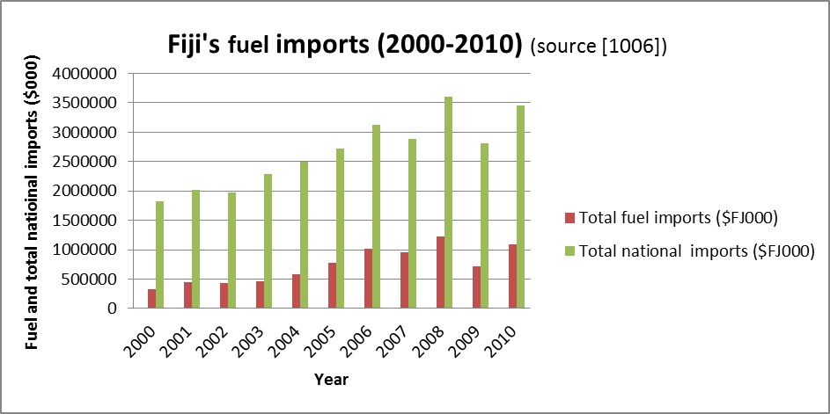

Figure 1 Fiji’s fuel import bill as compared to its total import bill over the last decade. The fuel bill exceeded one third of the total import bill in the year 2008.

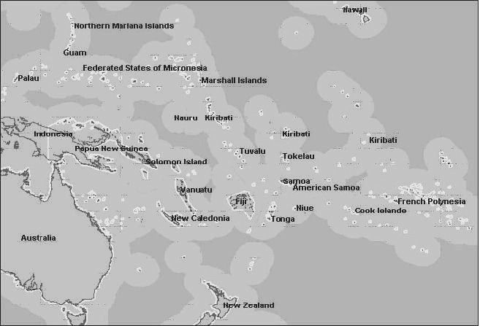
Figure 2 Map of the Pacific region. The countries to the north east, including Marshall Islands, Kiribati, Tuvalu, Cook Islands, French Polynesia and Niue are mainly coral atolls, with little manufacturing or mining activity, and have energy needs that are somewhat different from those of the volcanic islands such as Papua New Guinea and Fiji.

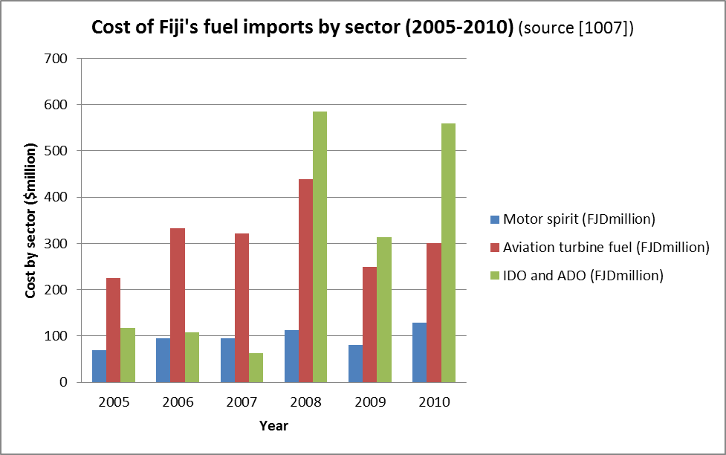

Figure 3 Costs of Fiji’s imported fuels by sector for the the period 2005-2010. The high proportion of the costs due to aviation turbine fuel (for airlines) is to be noted.

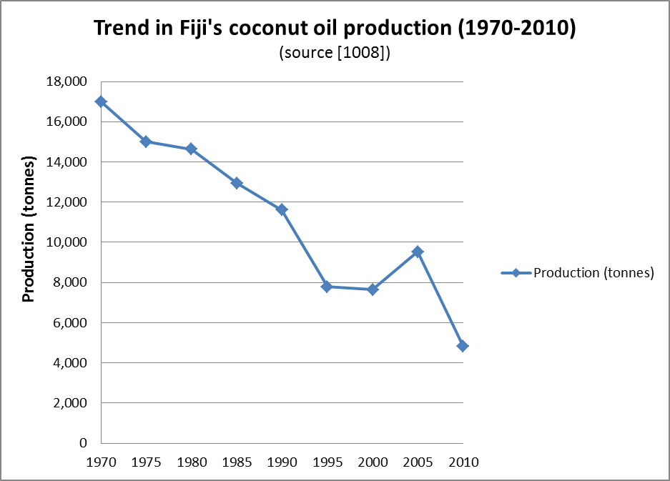

Figure 4 The declining trend in Fiji’s coconut oil production over the past three decades. The decline may be attributed to natural disasters such as tropical cyclones and droughts, but also include socio-economic factors.

Figure 5 Map of Fiji, showing the two main islands of Viti Levu and Vanua Levu, surrounded by the outer islands. Traditionally, copra produced on the outer island had to be transported to the main islands, adding to the production costs of coconut oil.

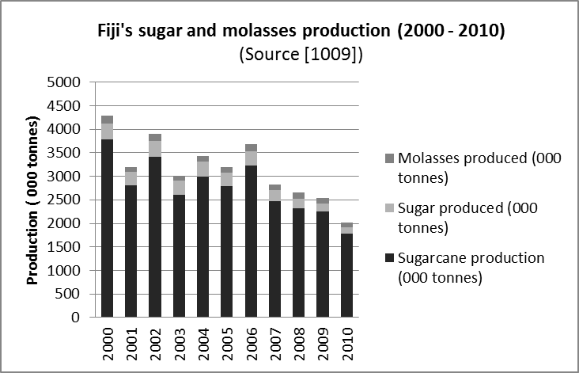

Figure 6 Chart showing Fiji’s sugar and molasses production from sugarcane over the past decade. Molasses is a feedstock for ethanol production. In 2010, Fiji produced 113,000 tonnes of molasses and 132,000 tonnes of sugar from 1,778,000 tonnes of sugarcane.

