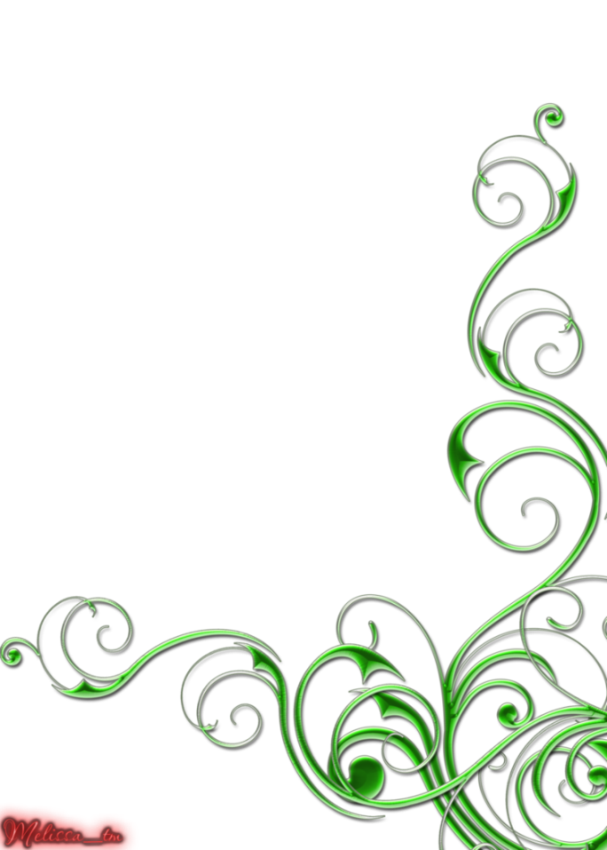

THE DENSITY OF VĀ
1angrnative on climate change in the Pacific

In the space between the bleeding sky and dawn
voices wail in an unfamiliar tongue.

in the space between my pito and my mother’s bones
A white owl watches two eel-gods
Dying
As a dog
Howls
Red earth into black Lua- two
and rock watersky lines pierce my throat
atua – god in my belly.

in the space between my head and my father’s teeth
There’s a stone
An ocean of tears
In my belly blood sand and a chant that is a scream
reaching inwardthen out
gutting melike a fish.

in the space between my belly and the chant
that is the bleeding sky
human skin is stretched across fired stones
tempered with my grandmothers’ tears
calling to the spirits of her people
I shout to the heavens between us
for a sign
because pulotu is not above us
it is in the sea.

in the space between pulotu and the words that bring my soul to life
There rests a broken, blackened shell
Gnarled and discarded
by the strangers who do not love us…
I am thrust into unforgiving arms
Where Moana reminds me that
Between/Within/And without
I am of the deep sea
Green Tanu and blue Vasa.

in the space between sleep and my grandfathers’ eyes
There is a dying flame
birthed from fire stolen from the fingers and toes of a dead god
and a fire in my belly
That is Pele wailing
I, she, we callfor Maui to wake and slow the sun again
to douse the fiery skies.

in the space between the fiery skies and a sleeping Maui
There is a bird
That is Tagaloa
And he roars
As I am impaled on a magic hook
That once pulled islands from the fire of the sea.

in the space between a bird and a magic hook
Rests the soft curve of a woman
That is a bloodclot
Hidden in my belly
Nafanua grinds her teeth against my bones
marking my body with black lines
inking my eyelids and tongue.

in the space between the open sea
There’s a fire in the sky
Fish die in boiling waves
Saumaiafe wakes the dead
Waiting for the end or the beginning
There’s a grinding of teeth in my belly and it hurts.

in the space between knowing and the known
There is a gathering of stillborn children to a mother’s breast
Remembering words now forgotten
in the language of trees
in my belly the roots of fringing reefs
clumped with blood and knotted hair.

in the space between knower and knowledge
we have become orphans
Blessed only with blood and pain
As Afunakwa sings of a bleeding heart
Dry salt in my belly
The secrets of birds are lost.

in the space between place and breath
our gods are condemned to the wind
the dreams of fish
Discarded by strangers who do not love us
fishhooks in my belly pull me to shore.

in the space between I am and I will
We measure the density of va
In the pit of my belly
There is a seed
And it is sadness.

in the space between climate justice and climate redemption
stands the one-eyed Hikuleo
her hair a tangle of black roots
In her belly the children of sky
brown as the earth is old
Their tears are 'the ocean in us'
In my belly
Hina of the moon
and she weeps.

© 1angrnative

Koya, C.F (2010). Performance Poem for "creativity and climate change' conference - poetry evening Sept 16, 2010

